Contents

SUBROUTINE CALLS 2

ACCESSING STACK PARAMETERS 16

BASE OFFSET ADDRESSING 20

EXPLICIT STACK PARAMETERS 24

CLEANING UP THE STACK 26

CALLING CONVENTIONS 30

SAVING AND RESTORING REGISTERS 35

LOCAL VARIABLES IN ASSEMBLY 38

REFERENCE PARAMETERS 43

LEA INSTRUCTION 46

ENTER AND LEAVE INSTRUCTIONS 48

LOCAL DIRECTIVE 49

RECURSION IN ASSEMBLY LANGUAGE 55

INVOKE, ADDR, PROC AND PROTO 64

ASSEMBLY TIME ARGUMENT CHECKING 74

WIRESTACKFRAME PROCEDURE 85

MULTIMODULE PROGRAMS 89

CALLING EXTERNAL PROCEDURES 92

ADVANCED OPTIONAL TOPIC 1 – USES OPERATOR 115

PASSING 8-BIT AND 16-BIT ARGUMENTS ON THE STACK 117

SUBROUTINE CALLS

Introduction to Subroutine Calls

This chapter covers the fundamental structure of subroutine calls, with a focus on the runtime stack. Subroutine calls are common in C and C++ programming, and debugging these calls can require an understanding of the runtime stack.

In C and C++, subroutines are referred to as **functions**, while in Java, they are known as **methods.** In MASM, they are termed **procedures.**

Values passed to a subroutine by a calling program are termed arguments. However, once these values are received by the called **subroutine**, they become **parameters**.

**Stack frames** are used to manage subroutine calls. A **stack frame** is a region of memory on the runtime stack that is used to store the subroutine's local variables and parameters.

* Subroutine calls are a fundamental part of low-level programming.
* The runtime stack is used to manage subroutine calls.
* **Arguments** passed to a subroutine **become parameters** within the subroutine.
* Stack frames are used to store local variables and parameters for subroutines.

Stack Frames

In this section, we'll delve into the concept of stack frames, specifically focusing on stack parameters.

I. Stack Parameters

In 32-bit mode, stack parameters are the norm for Windows API functions.

In 64-bit mode, Windows functions receive a combination of both register and stack parameters.

To pass a parameter to a subroutine on the stack, the **caller function pushes** the parameter onto the stack before calling the subroutine.

The subroutine then accesses the parameter by using the stack pointer register.

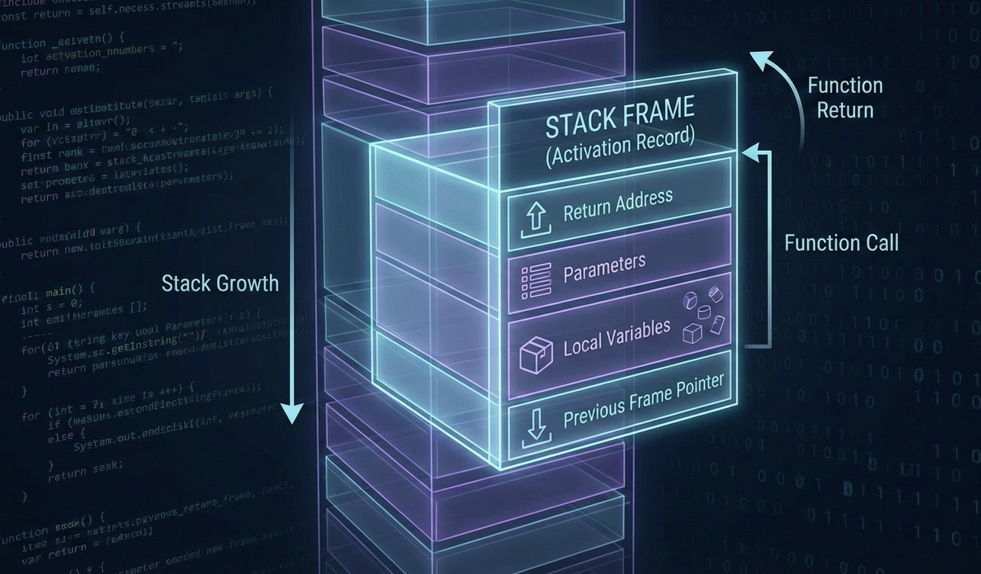

II. The Anatomy of a Stack Frame

A **stack frame** (also called an **activation record**) is a specific chunk of memory created on the stack every time a function (subroutine) is called.  
Think of it as the function’s **personal workspace** while it’s running.

This stack frame holds:

* Arguments passed to the function
* The return address (where execution should go after the function finishes)
* Local variables
* Saved registers

III. How a Stack Frame Is Built (Step by Step)

1. **Passed arguments** (if any) are pushed onto the stack first.
2. When the subroutine starts executing, the current value of the **Extended Base Pointer (EBP)** is pushed onto the stack.  
   This preserves the caller’s stack frame.
3. The **EBP is then set equal to the current Stack Pointer (ESP)**.  
   From this point on, EBP becomes a **stable reference point** for accessing:
   * Function parameters
   * Local variables
4. If the subroutine uses **local variables**, the **Stack Pointer (ESP) is decremented** to reserve space for them on the stack.

IV. Important Stack Behavior to Remember

* The stack starts at **higher memory addresses**.
* As values are pushed, **ESP decreases** → the stack **grows downward**.
* When values are popped, **ESP increases**.

This downward growth explains why space for parameters and local variables is allocated by decrementing the stack pointer.

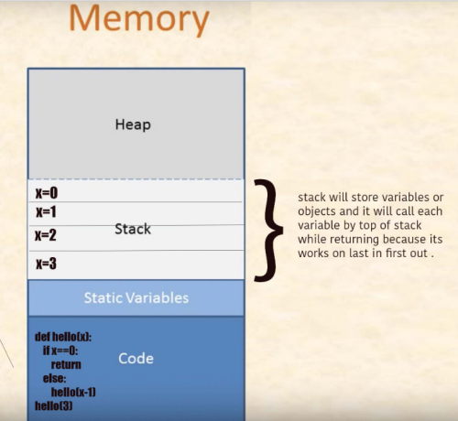

If certain **registers need to be preserved**, they are pushed onto the stack before the subroutine modifies them. This ensures their original values can be restored before returning control to the caller.

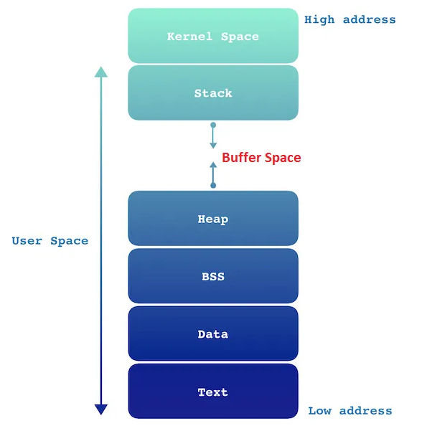

The **layout and organization of a stack frame** depend heavily on:

* The program’s **memory model**
* The **calling convention** used to pass arguments

**Why Argument Passing on the Stack Matters**

Understanding how arguments are passed on the stack is **crucial**, because most high-level programming languages rely on this mechanism.

For example:

* In **32-bit Windows API programming**, function arguments are typically passed **on the stack**.
* In **64-bit programming**, a different calling convention is used (many arguments are passed through registers instead).  
  We’ll explore this newer convention in detail in later chapters.

**Calls and the Stack (MASM Example)**

Consider a scenario where **“Reese”** (the calling, external procedure) calls **“Rennex”** (the called, internal procedure) in MASM.

Here’s what actually happens:

* When **Reese calls Rennex**, it is **Reese** that pushes **Rennex’s return address** onto the stack.
* This return address points to the exact instruction in **Reese** where execution should continue after **Rennex** finishes.
* In other words, **the caller (Reese)** is responsible for saving the return address.

**During Execution**

* **Rennex** runs its code normally.
* When Rennex reaches the RET instruction, it **uses the saved return address** to transfer control back to Reese.

**After the Return**

* Control returns to **Reese**.
* At this point, it is typically **Reese’s responsibility to clean up the stack**.
* Reese issues a **POP instruction** to remove the return address from the stack.
* This POP:
  + Retrieves the value at the top of the stack
  + Adjusts the **Stack Pointer (ESP)** accordingly

By doing this, Reese ensures:

* The stack remains balanced
* Program flow continues correctly

**About Stack Diagrams**

Some stack diagrams can look confusing at first, especially when multiple values are involved.  
However, the rule **never changes**:

The stack pointer **always points to the top of the stack**.

Even when the diagram looks complex, the underlying behavior of the stack remains the same.

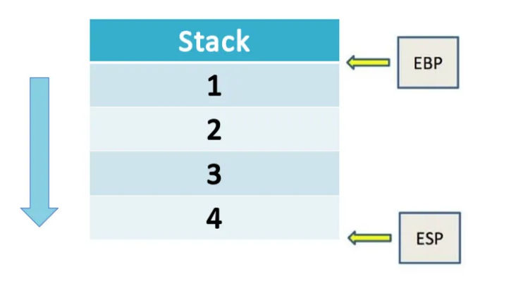

Right now, the stack pointer (ESP) is pointing at the very top of the current stack frame, and the value sitting there is 4.

The extended base pointer (EBP) is pointing lower down, at the bottom of this stack frame, where the value 1 lives.

At first glance this can feel a little backwards — because we usually think of memory addresses getting bigger as we go “up.” But here’s the key thing to remember:

The stack grows downward in memory.

That means every time you push something new onto the stack, it gets placed at a lower memory address than whatever was there before.

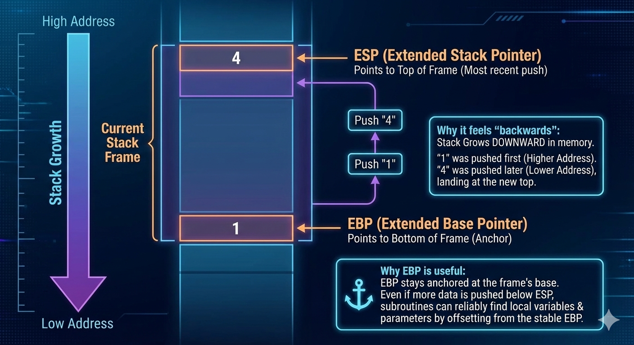

So, in the picture you’re looking at:

* First, the value 1 was pushed → it landed at a higher memory address
* Then the value 4 was pushed → it landed at a lower memory address

That’s why 1 ends up at the bottom of the stack frame, and 4 ends up at the top (even though 4 is the most recently added item).

And that’s exactly why we have EBP (the base pointer).

It stays parked at the bottom of the current stack frame — kind of like an anchor.

That way, even if the function you’re currently in pushes more stuff onto the stack later, your subroutine can still reliably find its own local variables and parameters by counting offsets from EBP. Super handy!

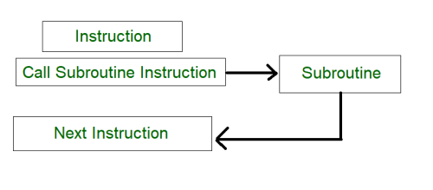

Stack Frames and Subroutine Calls

When a subroutine is called, the **EBP register** plays a central role in creating a stack frame:

1. **Setup:**
   * The current value of EBP is pushed onto the stack.
   * EBP is then set equal to ESP, marking the start of the new frame.
2. **Accessing variables:**
   * Local variables are accessed using negative offsets from EBP.
     + First local variable → [EBP-4]
     + Second local variable → [EBP-8]
     + And so on.
   * Parameters are accessed using positive offsets from EBP.
3. **Return:**
   * When the subroutine ends, the saved EBP is popped back from the stack.
   * This restores the previous stack frame, returning control cleanly to the caller.

Disadvantages of Register Parameters (Fastcall Convention)

Passing arguments in registers can be faster than using the stack, but it comes with trade‑offs:

* **Registers are multi‑purpose:**
  + The same registers used for parameters are also needed for loop counters, operands, and other tasks.
  + This means they often must be saved (pushed) before use and restored (popped) afterward.
* **Code clutter:**
  + Extra pushes and pops make the code harder to read and maintain.
* **Error risk:**
  + Every PUSH must be matched with a POP.
  + If execution paths diverge (e.g., multiple branches), it’s easy to mismatch pushes/pops, leaving registers stuck on the stack and causing unpredictable behavior.

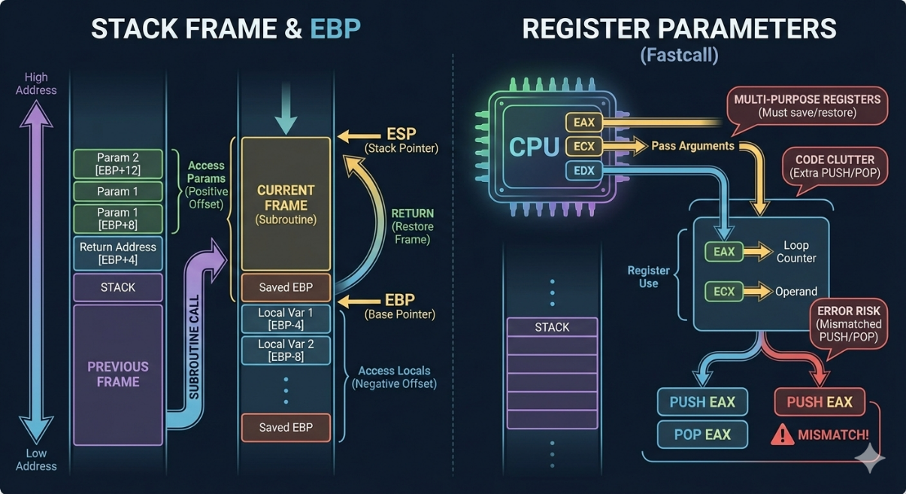

The following code shows an example of how register parameters can be used to call the DumpMem subroutine from the Irvine32 library:

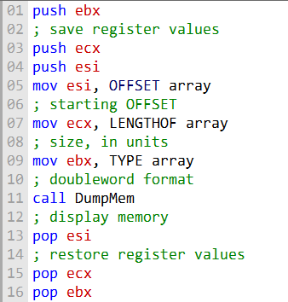

Saving and Restoring Registers with the Stack

When working with subroutines, registers often need to be preserved. This is done by **pushing** them onto the stack before the call and **popping** them back afterward. Because the stack operates in **LIFO (Last In, First Out)** order, the registers must be popped in the reverse order they were pushed.

Example Flow

1. **Before the call:**
   * EAX, EBX, and ECX are pushed onto the stack.
   * This saves their values so the subroutine can safely use them.
2. **Inside the subroutine (**DumpMem**):**
   * The registers are used to access and display memory.
3. **After the call:**
   * The saved values are popped back into EAX, EBX, and ECX.
   * This restores the original state of the registers.

Potential Pitfall

If the push/pop sequence is mismatched, the stack becomes unbalanced. For example:

* If EAX = 1 at line 8 and the procedure exits incorrectly, three register values remain on the stack.
* This prevents the procedure from returning properly at line 17, since the return address is buried under leftover data.

Key Takeaway

Always respect the **push/pop balance**. Every register pushed must be popped in reverse order, or the stack frame will break — leading to errors like failed returns or corrupted data.



Stack Parameters: The Nicer Way to Pass Arguments

When you want to send info (arguments) to a subroutine, using the stack is actually one of the cleanest and most flexible methods out there. The idea is super straightforward:

1. Before you call the subroutine, just push each argument you want to send onto the stack.
2. Then call the subroutine like normal.
3. Inside the subroutine, it can reach back and grab those values right off the stack.

That’s it! No weird registers to juggle, no fixed limits on how many arguments you can pass — the stack just grows to hold whatever you need. Here’s a quick real-world feel for it: Imagine you want to call a subroutine called DumpMem that needs three pieces of info:

* A starting memory address
* A length (how many bytes to dump)
* Maybe a flag or format option

Instead of cramming everything into registers (which can get messy fast), you’d do something like this in assembly:

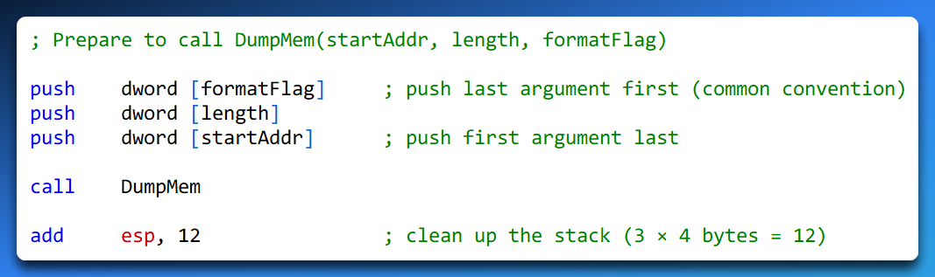

(The exact push order and cleanup style can vary depending on the calling convention, but the core idea stays the same.)

Pushing arguments onto the stack before the call means:

* The subroutine can easily find them relative to the EBP (base pointer) once it sets up its own stack frame
* You can pass as many arguments as you want (limited only by available stack space)
* It’s very reliable — especially useful in nested calls or when you have lots of parameters

It’s one of those things that feels a little “extra” at first, but once you get used to it, it becomes super natural and way less error-prone than trying to squeeze everything into registers.

I. Advantages of Stack Parameters

Stack parameters have a number of advantages over register parameters:

**More flexible**. Stack parameters can be used to pass any number of arguments to a subroutine, regardless of the number of registers available.



**More reliable.** Stack parameters are less susceptible to errors than register parameters. For example, there is no need to worry about matching every PUSH with a POP.



**Easier to maintain.** Code that uses stack parameters is typically easier to read and maintain than code that uses register parameters.



Stack parameters are the preferred way to pass arguments to subroutines in most cases. They offer a more flexible, reliable, and maintainable approach than register parameters.

Pass by Value

Let’s look at a super common way to pass arguments to a subroutine in MASM: passing by value using the stack.

When you pass something by value, you’re not sending the original variable — you’re pushing a copy of its value onto the stack.

Here’s the little MASM snippet we’re working with:

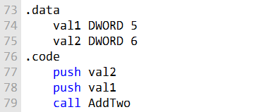

After the push instructions have been executed, the stack will look like this:

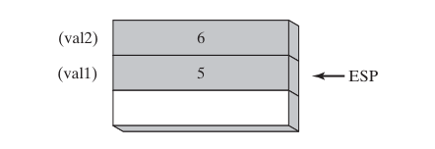

Notice something important:

* We pushed val2 (6) first
* Then we pushed val1 (5) second

Because the stack grows downward in memory (lower addresses), every new push makes ESP move to a lower address.

So, after both pushes:

* ESP is pointing at the most recently pushed value → val1 (5)
* val2 (6) is sitting just below it

This reverse-order pushing is the standard MASM / stdcall / Win32 calling convention trick.

It means the last argument you want the function to see gets pushed first.In C++ land, this code is basically doing the same thing as:

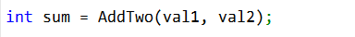

So, inside the AddTwo subroutine, once it sets up its stack frame (usually with push ebp; mov ebp, esp), the arguments are super easy to reach:

* At [ebp + 8] → first argument (val1 = 5)
* At [ebp + 12] → second argument (val2 = 6)

(Why +8 and +12? Because [ebp] holds the old EBP, [ebp+4] holds the return address, so arguments start at +8.)When AddTwo is done and wants to clean up, it pops those two arguments off the stack (or more commonly, the caller cleans up by doing add esp, 8 after the call). Either way, ESP gets bumped back up by 8 bytes (4 bytes × 2 arguments), so it points to whatever was on the stack before we started pushing.Quick recap of why this feels “backwards” at first:

* Stack grows down → new pushes → lower addresses → ESP moves down
* We push arguments right-to-left (last arg first) → so the first arg ends up closest to ESP
* ESP always points to the top (most recent) item

***======================***

***Pass by Reference***

***======================***

When an argument is passed by reference in MASM, the **address of the argument is pushed onto the stack.**

This allows the subroutine to modify the value of the original variable. The following MASM code shows how to call a subroutine named Swap, passing it two arguments by reference:

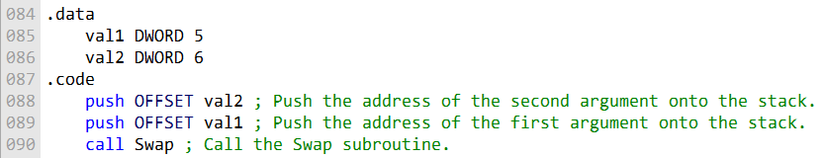

After the push instructions have been executed, the stack will look like this:

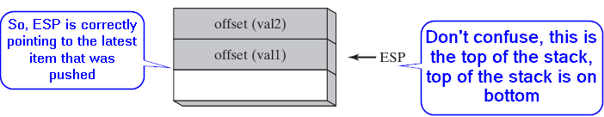

Stack grows downwards!!! I won't stop repeating that.

The ESP register points to the top of the stack, so the subroutine Swap can access the arguments by reading from the stack at offsets 0 and 4 bytes, respectively.

The subroutine Swap can then use these addresses to modify the values of the original variables, val1 and val2.

The following C code is equivalent to the MASM code above:

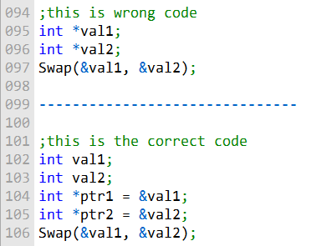

**The first code is wrong because the pointer variables val1 and val2 are not initialized. This means that they contain garbage values.**

* When the Swap function is called, it will expect to receive pointers to integers as arguments. However, the pointer variables **val1 and val2 will not contain pointers to integers,** so the Swap function will not be able to work correctly.
* Additionally, the Swap function will try to modify the values of the variables pointed to by val1 and val2. However, the pointer variables val1 and val2 will contain garbage values, so the Swap function will try to modify the values of garbage memory. This can lead to undefined behavior.

**The second code is correct because the pointer variables ptr1 and ptr2 are initialized to the addresses of the variables val1 and val2, respectively.**

* When the Swap function is called, it will receive pointers to integers as arguments, because the pointer variables ptr1 and ptr2 contain pointers to the variables val1 and val2.
* The Swap function will then be able to modify the values of the variables val1 and val2, because it has pointers to those variables.
* Therefore, the second code is correct, and the first code is wrong.
* It is important to initialize pointer variables before using them. This will ensure that they contain valid addresses, and that they will be able to point to the correct variables.

***Conclusion***

Passing by value and passing by reference are two different ways to pass arguments to a subroutine in MASM.

Passing by value is the default, and it is the safest way to pass arguments, because it prevents the subroutine from modifying the original variables.

***======================***

***Passing Arrays***

***======================***

High-level languages always pass arrays to subroutines by reference because it is more efficient and safer than passing them by value.

When **passing an array by reference**, the address of the array is pushed onto the stack. The subroutine can then get the address from the stack and use it to access the array.

This is much more efficient than passing the array by value, because it does not require each array element to be pushed onto the stack separately.

Additionally, **passing an array by reference is safer** than passing it by value. If the array is large, passing it by value can quickly **overflow the stack.**

When passing an array by reference, the **stack only needs to store the address of the array**, which is much smaller than the size of the array itself.

The following MASM code shows how to pass an array to a subroutine by reference:

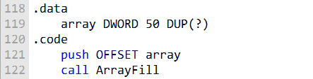

The OFFSET array operator returns the address of the array variable. So, the push OFFSET array instruction pushes the address of the array variable onto the stack.

The ArrayFill subroutine can then access the array by reading from the stack at offset 0 bytes. The following C code is equivalent to the MASM code above:

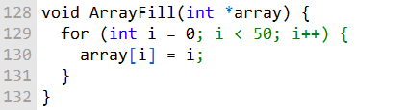

The array parameter is a pointer to the array. The subroutine can then access the array elements by dereferencing the array pointer.

Passing arrays by reference is the standard way to pass arrays to subroutines in both MASM and C. It is more efficient and safer than passing arrays by value.

ACCESSING STACK PARAMETERS

The **register 'ESP'** is used to point to the next item on the stack and is referred to as the 'stack pointer'. Is this false??

Yes, the statement "The register 'ESP' is used to point to the next item on the stack and is referred to as the 'stack pointer'" is wrong. The ESP register points to the top of the stack, which is the most recently pushed item. It only points to the next item after that item has been pushed.

The ESP register points to the top of the stack, which is the most recently pushed item.

The stack grows downwards, so when you push a value onto the stack, the ESP register is decremented by the size of the value. When you pop a value off the stack, the ESP register is incremented by the size of the value.

So, to answer your question, the ESP register points to the item that was last pushed onto the stack. For example, if you push the values 1, 2, and 3 onto the stack, the ESP register will point to the value 3.

This is because the value 3 was the last value to be pushed onto the stack. If you then pop a value off the stack, the ESP register will point to the value 2. This is because the value 2 is now the most recently pushed item on the stack.

**==============================================**

EBP aka the **'stack frame pointer'** serves as an unchanging reference point for data on the stack. This allows the program to work out how far away something in the stack is from this point.

A **stack frame** is a region of memory that is used to store the local variables and parameters of a function. Each function has its own stack frame, which is created when the function is called and destroyed when the function returns.

The **number of stack frames that can be active at any given time depends** on the depth of the call stack. The call stack is a list of all the functions that are currently executing. The depth of the call stack is the number of functions in the call stack.

For example, if the following function calls are made:

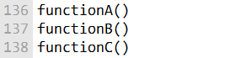

Then the call stack will be as follows:

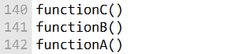

There will be three stack frames active, one for each function in the call stack.

The stack frames are nested, with the stack frame for the most recently called function at the top of the stack.

When a function returns, its stack frame is destroyed and the stack pointer is moved back to the previous stack frame.

The maximum **number of stack frames** that can be active is limited by the size of the stack. The stack is a region of memory, so it has a finite size. If the stack overflows, the program will crash.

Most operating systems have a default stack size, but this can be changed. The stack size can be increased to allow for deeper call stacks, but this will reduce the amount of memory available for other purposes.

The number of stack frames that are typically active in a program depends on the type of program. **Programs that use recursion** can have very deep call stacks. Programs that use a lot of functions can also have deep call stacks.

In general, it is best to **avoid having very deep call stacks.** Deep call stacks can lead to stack overflows and can also make programs more difficult to debug.

***============================***

***Accessing Stack Parameters***

***============================***

High-level languages have various ways of initializing and accessing parameters during function calls. In C and C++, this is done through the use of a stack frame.

A stack frame is a region of memory that is allocated on the stack when a function is called. It contains the function's parameters, local variables, and saved registers.

The following is an example of a simple C function:

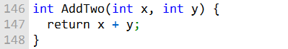

When this function is called, the compiler will generate a prolog and an epilog. The prolog saves the EBP register and points EBP to the top of the stack. The epilog restores the EBP register and returns to the caller.

The following is an example of an assembly language implementation of the AddTwo function:

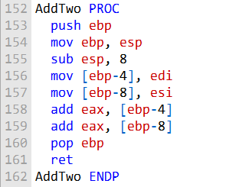

The first instruction, push ebp, saves the EBP register on the stack. The second instruction, mov ebp, esp, points EBP to the top of the stack. This creates a new stack frame for the AddTwo function.

The next instruction, sub esp, 8, reserves 8 bytes of space on the stack for the two parameters. The two following instructions, mov [ebp-4], edi and mov [ebp-8], esi, store the parameters in the stack frame.

The next two instructions, add eax, [ebp-4] and add eax, [ebp-8], add the two parameters together and store the result in the EAX register.

The final two instructions, pop ebp and ret, restore the EBP register and return to the caller.

When the AddTwo function is called, the compiler will generate code to push the two parameters on the stack in reverse order.

The first parameter will be pushed last, and the second parameter will be pushed first. This is because the stack grows downwards.

***The following figure shows the contents of the stack frame after the function call AddTwo(5, 6):***

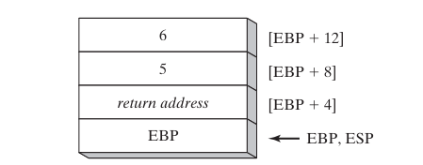

AddTwo could push additional registers on the stack without altering the offsets of the stack parameters from EBP. ESP would change value, but EBP would not.

Here is a rewritten explanation of the image, based on the description you gave me:

The image shows a stack frame for a function with two parameters. The stack frame is a region of memory that is allocated on the stack when a function is called. It contains the function's parameters, local variables, and saved registers.

The stack frame grows downwards, so the parameters are pushed onto the stack in reverse order. The first parameter is pushed last, and the second parameter is pushed first.

***The image shows the following:***

**The function we are dealing with is AddTwo(5,6):** 6 is the last parameter, be pushed first into the stack.

When a function is called, the **parameters are pushed onto the stack in reverse order**. This means that the last parameter is pushed first, and the first parameter is pushed last.

**6:** The second parameter for the function AddTwo.

**5:** The first parameter for the function AddTwo.

**[EBP + 12]:** The address of the second parameter for the function AddTwo.

**[EBP + 8]:** The address of the first parameter for the function AddTwo.

**[EBP + 4]:** is the address of the EBP register for the calling function. This means that it stores the address of the stack frame for the calling function.

When a function is called, the compiler generates code to save the EBP register and point EBP to the top of the stack. This creates a new stack frame for the function.

The address of the EBP register for the calling function is stored at [EBP + 4]. This ensures that the function can return to the calling function when it is finished executing.

When the function is ready to return, it pops the return address off the stack and restores the EBP register. This restores the stack frame for the calling function, and the function returns.

**EBP:** The base pointer for the stack frame. This is the address of the **start of the stack frame.**

**EBP, ESP:** The EBP and ESP registers.

---------------------------------------------

Here is an example of how EBP is used to access the parameters and local variables for a function:

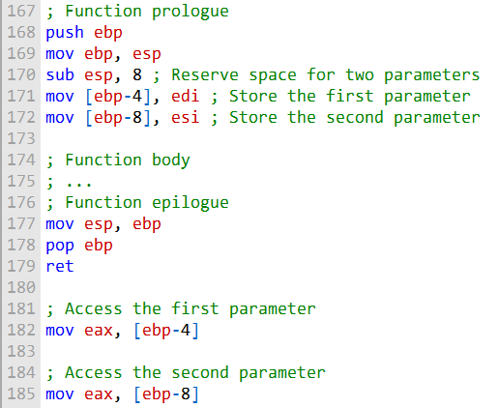

BASE OFFSET ADDRESSING

The following code is a rewritten and explained implementation of AddTwo using base-offset addressing to access stack parameters:

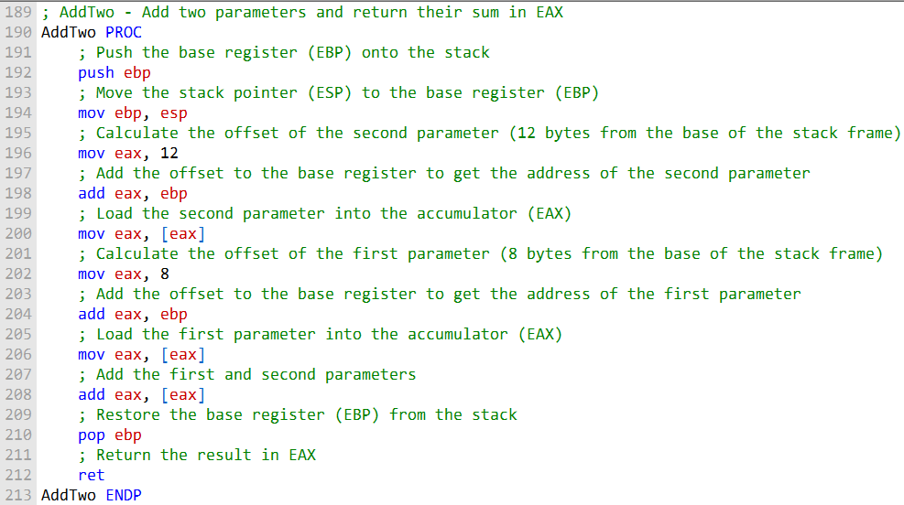

***Explanation:***

The first instruction, **push ebp**, saves the base register (EBP) onto the stack. This is important because EBP will be used as the base register for accessing stack parameters.



The next instruction, **mov ebp, esp**, moves the stack pointer (ESP) to the base register (EBP). This effectively sets the base of the stack frame.

The next two instructions, **mov eax, 12** and **add eax, ebp,** calculate the offset of the second parameter. The second parameter is located 12 bytes from the base of the stack frame.

The next instruction, **mov eax, [eax]**, loads the second parameter into the accumulator (EAX).



The next two instructions, **mov eax, 8** and **add eax, ebp**, calculate the offset of the first parameter. The first parameter is located 8 bytes from the base of the stack frame.

The next instruction, **mov eax, [eax]**, loads the first parameter into the accumulator (EAX).

The next instruction, **add eax, [eax]**, adds the first and second parameters.

The next instruction, **pop ebp**, restores the base register (EBP) from the stack.



This is important because we need to restore the base register before returning from the function. The final instruction, **ret**, returns from the function. Example usage:

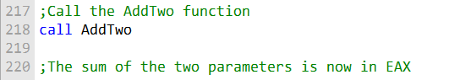

***Benefits of using base-offset addressing:***

Base-offset addressing is efficient because it allows us to access stack parameters without having to calculate their absolute addresses.

Base-offset addressing is also **flexible** because it allows us to access stack parameters relative to the base of the stack frame.



This means that we can easily move the stack frame around without having to update the code that accesses stack parameters.

Image 1:

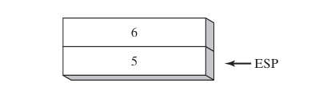

Image 2:

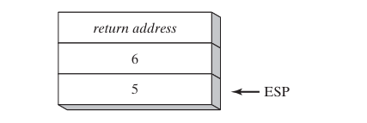

EXPLICIT STACK PARAMETERS

**Explicit stack parameters** are stack parameters that are referenced by their offset from the base pointer register (EBP).

This is in contrast to implicit stack parameters, which are referenced by their position in the stack frame.

The following code shows an example of how to use explicit stack parameters in an assembly language procedure:

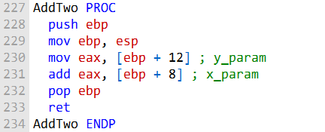

This procedure takes two arguments, x and y, and returns the sum of those two arguments. The arguments are passed to the procedure on the stack.

The procedure begins by pushing the EBP register onto the stack. This is done to preserve the value of EBP, which is used as the base pointer for the stack frame.

The procedure then moves the ESP register to EBP. This sets EBP to point to the top of the stack frame.

Next, the procedure loads the first argument, y, from the stack.

This is done by using the mov instruction to load the value from the address [ebp + 12].

The [ebp + 12] offset is the offset of the first argument from the base pointer register.

The procedure then adds the second argument, x, to the first argument.

This is done by using the add instruction to add the value from the address [ebp + 8] to the value in the EAX register.

The [ebp + 8] offset is the offset of the second argument from the base pointer register.

Finally, the procedure pops the EBP register from the stack.

This restores the original value of EBP.

The procedure then returns by using the ret instruction.

***The following is a more in-depth explanation of the code:***

**push ebp:** This instruction pushes the EBP register onto the stack. This is done to preserve the value of EBP, which is used as the base pointer for the stack frame.

**mov ebp, esp:** This instruction moves the ESP register to EBP. This sets EBP to point to the top of the stack frame.

**mov eax, [ebp + 12]:** This instruction loads the first argument, y, from the stack. This is done by using the mov instruction to load the value from the address [ebp + 12]. The [ebp + 12] offset is the offset of the first argument from the base pointer register.

**add eax, [ebp + 8]:** This instruction adds the second argument, x, to the first argument. This is done by using the add instruction to add the value from the address [ebp + 8] to the value in the EAX register. The [ebp + 8] offset is the offset of the second argument from the base pointer register.

**pop ebp:** This instruction pops the EBP register from the stack. This restores the original value of EBP.

**ret:** This instruction returns from the procedure. Explicit stack parameters can be useful for making code more readable and maintainable.

For example, the following code uses symbolic constants to represent the explicit stack parameters:

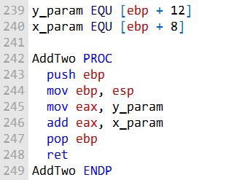

This code is more readable and maintainable because it **uses symbolic constants** to represent the explicit stack parameters. This makes it easier to understand what the code is doing and to make changes to the code in the future.

CLEANING UP THE STACK

To remove parameters from the stack when a subroutine returns, the subroutine must perform stack cleanup. Stack cleanup is the process of removing the subroutine's parameters from the stack so that the stack can be used by other subroutines.



There are two ways to perform stack cleanup:

**Explicit stack cleanup:** The subroutine explicitly removes its parameters from the stack using the POP instruction. This is done by popping the parameters off the stack in reverse order from which they were pushed.



**Implicit stack cleanup:** The subroutine leaves the stack cleanup to the caller. This is done by using a CALL instruction that specifies the number of bytes to be removed from the stack when the subroutine returns.



The following example shows how to perform **explicit stack cleanup** in the AddTwo subroutine:

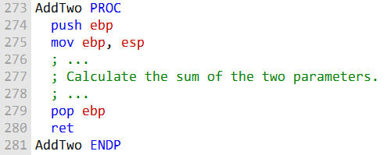

The pop ebp instruction at the end of the subroutine removes the base pointer register (EBP) from the stack.

This is done to restore the original value of EBP, which was pushed onto the stack at the beginning of the subroutine.

The following example shows how to use **implicit stack cleanup** in the AddTwo subroutine:

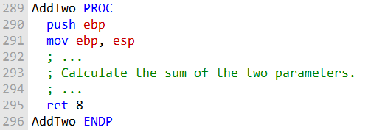

The ret 8 instruction at the end of the subroutine tells the caller to remove 8 bytes from the stack when the subroutine returns.

This is the same as the size of the two parameters that were pushed onto the stack at the beginning of the subroutine.

***===================***

***Stack OverFlow***

***===================***

Assuming that AddTwo leaves the two parameters on the stack, the following illustration shows the stack after returning from the call:

This image shows the stack after the call AddTwo instruction in main has been executed:

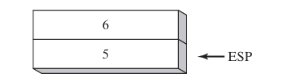

Inside main, we might try to ignore the problem and hope that the program terminates normally. But if we were to call AddTwo from a loop, the stack could overflow.

Each call uses 12 bytes of stack space - 4 bytes for each parameter, plus 4 bytes for the CALL instruction’s return address. A more serious problem could result if we called Example1 from main, which in turn calls AddTwo:

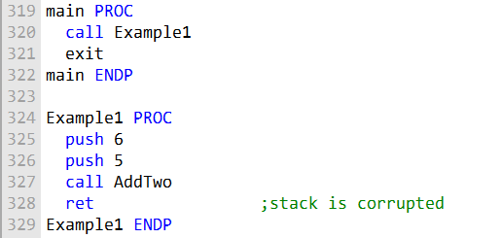

In the image below, the return address for the **call AddTwo** instruction is still on the stack. This is because the AddTwo subroutine did not perform any stack cleanup.

When the RET instruction in Example1 is about to execute, ESP points to the integer 5 rather than the return address that would take it back to main:

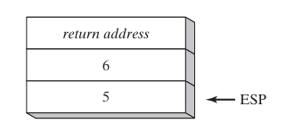

The RET instruction loads the value 5 into the instruction pointer and attempts to transfer control to memory address of 5.

Assuming that this address is outside the program’s code boundary, the processor issues a **runtime exception**, which tells the OS to terminate the program.

***Are these notes well organized??***

Yes, your notes are in good order and well explained. You have clearly explained the problem of stack corruption and how to prevent it. You have also provided a good example of how stack corruption can occur.

**Stack overflow:** Stack overflow occurs when the stack uses more memory than is available. This can happen if a subroutine leaves its parameters on the stack when it returns.

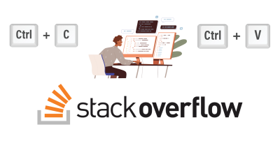

**Stack corruption:** Stack corruption occurs when the stack is not used correctly. This can happen if a subroutine does not perform stack cleanup or if a subroutine accesses the stack incorrectly.



**Preventing stack corruption:** To prevent stack corruption, subroutines must perform stack cleanup when they return. This can be done explicitly or implicitly. Your example of Example1 is a good example of how stack corruption can occur.



If the Example1 subroutine does not perform stack cleanup, the stack will be corrupted when the ret instruction is executed. This will cause the program to terminate with a runtime exception.

CALLING CONVENTIONS

Here is a simplified explanation of the **C** and **STDCALL** calling conventions.

***=================================***

***C calling convention:***

***=================================***

***Parameter passing:*** Parameters are pushed onto the stack in reverse order.

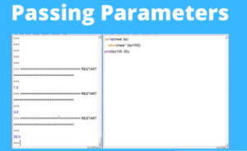

**Stack cleanup:** The caller is responsible for cleaning up the stack after the function returns.



***=================================***

***STDCALL calling convention:***

***=================================***

**Parameter passing:** Parameters are pushed onto the stack in reverse order.

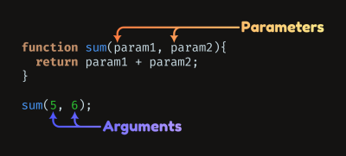

**Stack cleanup:** The called function is responsible for cleaning up the stack after it returns.



In other words, with the C calling convention, the caller has to tell the called function how many parameters it is passing.

With the STDCALL calling convention, the called function knows how many parameters it is receiving because it is responsible for cleaning up the stack.

Here is an example of a function call using the C calling convention:

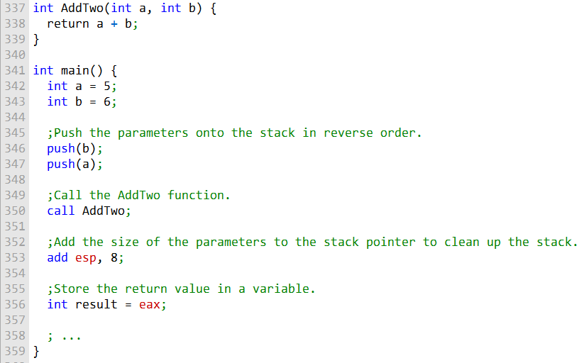

Here is an example of a function call using the STDCALL calling convention:

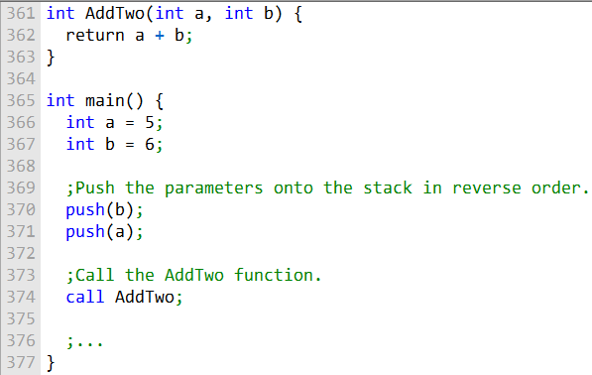

As you can see, the only difference between the two calling conventions is who is responsible for cleaning up the stack. With the C calling convention, the caller is responsible. With the STDCALL calling convention, the called function is responsible.

The STDCALL calling convention is used by the Windows API, so it is important to be familiar with it if you are writing programs that call Windows API functions.

***==============================***

***Useless stuff you don't need:***

***==============================***

There are many different calling conventions, each with its own advantages and disadvantages. Some common calling conventions include:

**C calling convention:** This calling convention is used by the C and C++ programming languages. It is simple to implement, but it can be inefficient for functions with many parameters.



**STDCALL calling convention:** This calling convention is used by the Windows API. It is more efficient than the C calling convention for functions with many parameters, but it is more complex to implement. x64 calling convention: This calling convention is used by 64-bit x86 processors. It is similar to the STDCALL calling convention, but it has been optimized for 64-bit performance.

[](https://encrypted-tbn0.gstatic.com/images?q=tbn:ANd9GcRpkzVi6rcG2CWPwwhCg_7seUYRjXQ35HM7Vw&usqp=CAU)

**Pascal calling convention:** This calling convention is used by the Pascal programming language. It is similar to the C calling convention, but it passes the first parameter in a register instead of on the stack.



**FORTRAN calling convention:** This calling convention is used by the FORTRAN programming language. It is different from the other calling conventions in that it passes all parameters in registers, rather than on the stack. In addition to these general-purpose calling conventions, there are also many specialized calling conventions that are used for specific purposes.



For example, there are calling conventions for operating system calls, library functions, and even specific types of functions, such as floating-point functions.

The number of calling conventions that exist depends on the specific processor architecture and programming language. However, there are a few common calling conventions that are used by most processors and programming languages.

SAVING AND RESTORING REGISTERS

Subroutines often save the current contents of registers on the stack before modifying them.

This is a good practice, because the original values can be restored just before the subroutine returns.

This ensures that the subroutine does not modify registers that are used by the caller, and that the caller's state is preserved.

The ideal time to save registers is just after setting EBP to ESP, and just before reserving space for local variables.

This is because the stack grows below EBP, so pushing registers does not affect the displacement from EBP of parameters already on the stack.

Here is an example of a subroutine that saves and restores registers:

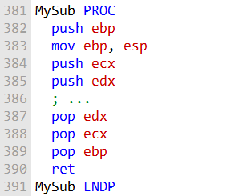

The subroutine first pushes the base pointer (EBP) onto the stack. This saves the current value of the stack pointer, which is used as the base of the stack frame for the subroutine. The subroutine then moves the stack pointer to EBP, which makes EBP the base of the stack frame for the subroutine.

The subroutine then pushes the ECX and EDX registers onto the stack. These are two commonly used registers, so it is a good practice to save them before modifying them.

The subroutine then performs its work.

Before returning, the subroutine restores the ECX and EDX registers from the stack. It also pops the base pointer (EBP) from the stack, which restores the stack pointer to its original value.

***Stack Frames***

A stack frame is a region of the stack that is used to store the local variables and parameters of a subroutine. The stack frame is created when the subroutine is called, and it is destroyed when the subroutine returns.

The base pointer (EBP) register is used to point to the base of the stack frame. This allows the subroutine to access its local variables and parameters without having to keep track of the stack pointer explicitly.

Here is a diagram of a stack frame for the MySub procedure:

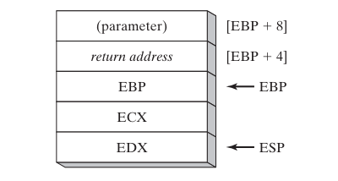

The **stack pointer (ESP)** is a register that points to the top of the stack. When a function is called, the caller pushes the function's parameters onto the stack and then calls the function. The called function then allocates space for its local variables on the stack.

**In the case of MySub**, the caller pushes two parameters onto the stack. When MySub is called, it first **saves the current value of the EBP register** onto the stack. This is because the EBP register is used to reference the stack frame for the current function.

MySub then **moves the ESP register into the EBP register.** This makes the EBP register point to the top of the stack frame for MySub. **MySub can then access its local variables** by using the EBP register as a base pointer.

The **first parameter to MySub is stored at [ESP + 8]**. This is because the ESP register points to the top of the stack, and the first parameter was pushed onto the stack **before** the EBP register was pushed onto the stack.

The **return address for MySub is stored at [ESP + 4].** This is because the return address is the next instruction that will be executed after MySub returns. The return address is pushed onto the stack by the caller **before** the caller calls MySub.

The **EBP register** is stored at [ESP]. This is because the EBP register is used to reference the stack frame for the current function.

The **ECX and EDX registers are stored at [EBP - 4] and [EBP - 8]**, respectively. This is because the ECX and EDX registers are **callee-saved registers**. This means that the caller is responsible for saving and restoring the values of these registers before and after calling MySub.

MySub can access its local variables by using the EBP register as a base pointer. For example, to access the first local variable, MySub would use the following instruction:

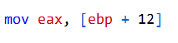

This instruction would copy the contents of the memory location at offset 12 from the EBP register into the EAX register.

When MySub is finished executing, it **pops the ECX and EDX registers off of the stack.** It then pops the EBP register off of the stack. This restores the EBP register to its previous value, which was the EBP register for the calling function.

Finally, **MySub executes the RET instruction.** This instruction returns to the caller and pops the return address off of the stack. The caller then executes the next instruction after the call to MySub.

***Conclusion***

Saving and restoring registers is a good practice for subroutines, because it ensures that the subroutine does not modify registers that are used by the caller, and that the caller's state is preserved. Stack frames are used to store the local variables and parameters of a subroutine.

LOCAL VARIABLES IN ASSEMBLY

The C++ function MySub() declares two local variables, X and Y. When this function is compiled into machine language, the following assembly code is generated:

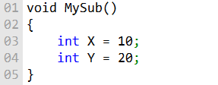

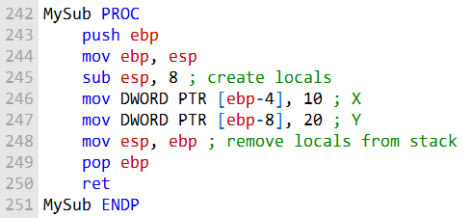

This assembly code shows how local variables are allocated on the stack. The push ebp and mov ebp, esp instructions save the current value of the EBP register onto the stack. The EBP register is used to reference the stack frame for the current function.

The sub esp, 8 instruction allocates 8 bytes on the stack for the two local variables. This is because each stack entry defaults to 32 bits, and each variable's storage size is rounded upward to a multiple of 4.

The mov DWORD PTR [ebp-4], 10 and mov DWORD PTR [ebp-8], 20 instructions initialize the local variables X and Y to the values 10 and 20, respectively.

When MySub() is finished executing, the mov esp, ebp and pop ebp instructions remove the local variables from the stack and restore the previous value of the EBP register.

The image you sent shows the stack frame for the MySub() function. The following table shows the contents of the stack frame:

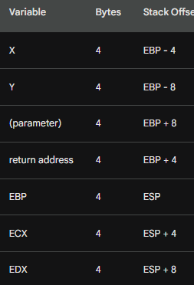

The first column in the table shows the name of the variable. The second column shows the number of bytes that the variable occupies in memory. The third column shows the stack offset of the variable. The stack offset is the distance from the base pointer (EBP) to the variable.

The X and Y variables are local variables. This means that they are created and destroyed within the current function. Local variables are allocated on the stack. In the image you sent, the X variable is located at stack offset -4, and the Y variable is located at stack offset -8.

The (parameter) variable is a parameter to the current function. Parameters are passed to functions by pushing them onto the stack before the function is called. In the image above, the parameter is located at stack offset 8.

The return address is the address of the instruction that will be executed after the current function returns. The return address is pushed onto the stack by the caller before the caller calls the current function. In the image you sent, the return address is located at stack offset 4.

The EBP register is the base pointer register. The base pointer register is used to reference the stack frame for the current function. In the image above, the EBP register is located at the same address as the ESP register.

The ECX and EDX registers are **callee-saved registers.** This means that the caller is responsible for saving and restoring the values of these registers before and after calling the current function. In the image you sent, the ECX and EDX registers are located at stack offsets 4 and 8, respectively.

-------------------------------------

The stack offset of a variable is the distance from the base pointer (EBP) to the variable. In the case of the X and Y variables, their stack offsets are -4 and -8, respectively.

This means that the X variable is located 4 bytes below the EBP register, and the Y variable is located 8 bytes below the EBP register.

The stack grows downward in memory, so the stack offset of a variable is the distance from the base pointer (EBP) to the variable in bytes, going down the stack.

The **EBP register** is used to reference the stack frame for the current function. This means that the X and Y variables can be accessed by using the EBP register as a base pointer.

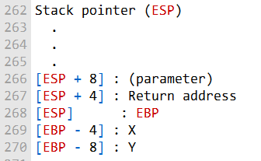

The following diagram shows the stack frame for the MySub() function, with the stack offsets of the X and Y variables indicated: (you can use the image above or this one):

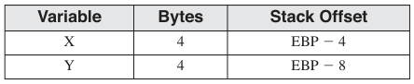

The EBP register is used to reference the **stack frame for the current function.** This means that the X and Y variables can be accessed by using the EBP register as a base pointer. For example, to access the X variable, the following instruction would be used:

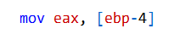

This instruction would copy the contents of the memory location at stack offset -4 into the EAX register.

The stack offset of a variable is also important for function calls. When a function is called, the caller pushes the function's parameters onto the stack.

The called function then allocates space on the stack for its local variables. The stack offset of a parameter is its distance from the EBP register in the caller's stack frame.

The stack offset of a local variable is its distance from the EBP register in the called function's stack frame.

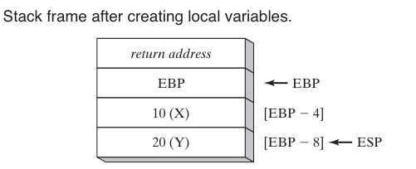

***=================================***

***Local Variables Symbols***

***=================================***

It is often useful to define a symbol for each local variable's offset. This can make the code easier to read and maintain.

To define a symbol for a local variable's offset, you use the **EQU directive.** For example, the following code defines a symbol for the X local variable:

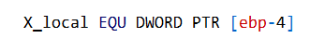

This symbol can then be used to access the X local variable, as shown in the following code:

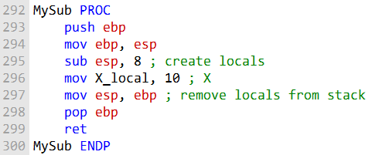

The line of code **X_local EQU DWORD PTR [ebp-4]** defines a symbol called X_local. This symbol is equivalent to the value of the memory location at stack offset -4.

The stack offset of a variable is the distance from the base pointer (EBP) to the variable in bytes, going down the stack. In this case, the stack offset is -4, which means that the variable is located 4 bytes below the base pointer.

The DWORD PTR keyword specifies that the variable is a 32-bit DWORD (double word).

This symbol can then be used to access the local variable X, as shown above.

Using symbols to access local variables can make the code easier to read and maintain. For example, the following code is easier to read than the previous code:

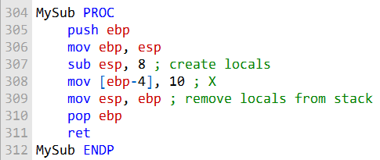

REFERENCE PARAMETERS

**Reference parameters** are passed to a procedure by address.

This means that the procedure receives a pointer to the actual variable, instead of a copy of the variable's value.

This allows the procedure to modify the value of the variable in the caller's scope.

To access a reference parameter, the procedure can use base-offset addressing with the EBP register.

The EBP register points to the base of the current stack frame.

Each reference parameter is pushed onto the stack in reverse order, so the offset of the first reference parameter is 12 bytes from EBP.

For example, the following code loads the pointer to the array passed to the ArrayFill procedure into the ESI register:



The ESI register can then be used to access the elements of the array.

The ArrayFill procedure fills an array with a pseudorandom sequence of 16-bit integers.

It receives two arguments: a pointer to the array and the array length.

The first argument is passed by reference and the second argument is passed by value.

Here is a simplified version of the ArrayFill procedure:

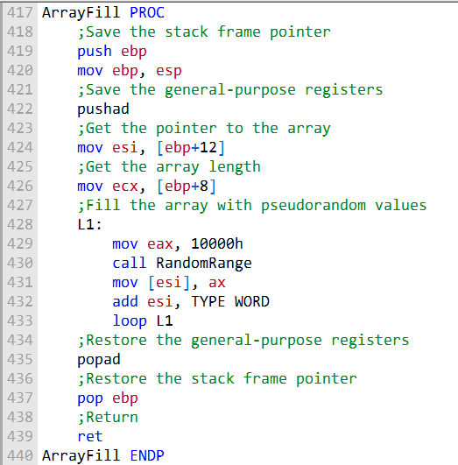

The first few lines of the procedure save the stack frame pointer and the general-purpose registers. Then, the procedure gets the pointer to the array and the array length from the stack.

The procedure then loops through the array and fills each element with a pseudorandom value using the RandomRange function. The RandomRange function is a library function that generates a random number between 0 and FFFFh.

After the loop, the procedure restores the general-purpose registers and the stack frame pointer, and then returns.

----------------------------------------------

The ArrayFill procedure is written in assembly language and serves the purpose of filling an array with pseudorandom values. Here's a detailed breakdown of how it works:

***Procedure Declaration:***

The ArrayFill PROC statement indicates the beginning of the procedure.

***Prologue - Saving the Stack Frame:***

push ebp: This instruction pushes the current stack frame pointer onto the stack. mov ebp, esp: Here, the current stack pointer (esp) is copied into the base pointer (ebp). This step is essential for setting up a new stack frame for the function.

***Saving General-Purpose Registers:***

pushad: The pushad instruction is used to save the values of all general-purpose registers (EAX, ECX, EDX, EBX, ESI, EDI, and EBP) on the stack. This is done to preserve the state of these registers during the execution of the procedure.

***Getting Array Pointer and Length:***

mov esi, [ebp+12]: This line loads the address of the array into the esi register. mov ecx, [ebp+8]: The value of the array length is loaded into the ecx register. These values are passed as parameters to the function, with [ebp+12] representing the array pointer and [ebp+8] representing the array length. Array Filling Loop: The labeled loop, L1, is the core of the procedure.

***In each iteration:***

mov eax, 10000h: The eax register is loaded with the value 10000h (40960 in decimal). call RandomRange: This likely calls a function named RandomRange to generate pseudorandom values. mov [esi], ax: The result of the RandomRange call is stored in the memory location pointed to by esi. add esi, TYPE WORD: The esi register is incremented by the size of a word, effectively pointing to the next element in the array.

***loop L1:***

This checks if the loop counter (ecx) is not zero and decrements it. If it's not zero, the code jumps back to L1, continuing the array filling process.

***Epilogue - Restoring Registers and Exiting:***

popad: This instruction restores the values of the general-purpose registers to their original state. pop ebp: It pops the stack frame pointer (ebp) to restore the previous stack frame.

ret: Finally, the ret instruction is used to return from the procedure, effectively exiting it. In summary, the ArrayFill procedure follows a standard structure: it saves the current state, sets up a loop to fill the array with pseudorandom values, and then restores the saved state before exiting. It's a crucial part of the code for filling an array with random data.

***Conclusion***

Reference parameters are a powerful feature of assembly language that allow procedures to modify the values of variables in the caller's scope. By understanding how to use reference parameters, you can write more efficient and reusable assembly code.

LEA INSTRUCTION

The OFFSET directive in assembly language allows you to get the address of a variable or label at compile time. However, **it does not work with stack parameters** because the addresses of stack parameters are not known until runtime.

The following statement would not assemble:

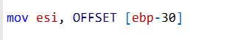

This is because the **compiler does not know the value of ebp at compile time.** ebp is the base pointer register, and it points to the top of the stack frame.

The offset of the local variable myString from the base pointer is -30, but the value of the base pointer is not known until runtime.

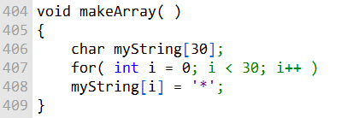

The code then enters a for loop that iterates from i = 0 to i = 29. In each iteration, it assigns the character '*' to the i-th element of the myString array.

Effectively, this code initializes all 30 elements of the myString array to the character '*'. After the function is called, the myString array will contain 30 asterisk characters, like this:

The **LEA instruction, on the other hand, can be used to calculate the address of a stack parameter at runtime.** The LEA instruction takes a memory operand as its operand and loads the effective address of the operand into the destination register.

The following assembly language code is equivalent to the C++ code in the example:

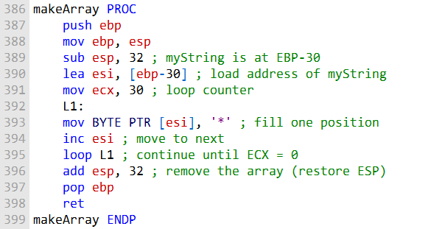

The LEA instruction calculates the effective address of the operand [ebp-30] and loads it into the register esi. The operand [ebp-30] references the local variable myString because myString is located 30 bytes below the base pointer register.

Once you have loaded the address of the stack parameter into a register, you can use the register to access the stack parameter. For example, the following assembly language code shows how to use the register esi to access the local variable myString:



This code stores the character '*' in the first byte of the local variable myString.

The LEA instruction is a powerful tool that can be used to calculate the addresses of memory locations at runtime. It is especially useful for working with stack parameters and dynamic data structures.

ENTER AND LEAVE INSTRUCTIONS

The ENTER and LEAVE instructions are used to manage stack frames in assembly language.

The **ENTER instruction** creates a stack frame for a called procedure, while the **LEAVE instruction** destroys the stack frame for the current procedure.

The ENTER instruction takes two operands: the number of bytes of stack space to reserve for local variables and the lexical nesting level of the procedure.

The lexical nesting level is the number of nested function calls that have occurred to reach the current function. In most cases, the lexical nesting level is zero.

***The ENTER instruction performs the following actions:***

Pushes the value of the EBP register onto the stack.

Sets the EBP register to the address of the current stack frame.

Reserves the specified number of bytes of stack space for local variables.

***The LEAVE instruction performs the following actions:***

Pops the value of the EBP register from the stack.

Restores the ESP register to its value before the ENTER instruction was executed.

The following example shows how to use the ENTER and LEAVE instructions to create and destroy a stack frame for a procedure:

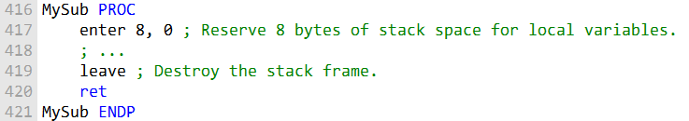

It is important to note that the ENTER and LEAVE instructions should be used together. If you use the ENTER instruction to create a stack frame, you must also use the LEAVE instruction to destroy the stack frame. Otherwise, the stack space that you reserved for local variables will not be released.

The image that you provided shows the stack before and after the ENTER instruction has executed. The ENTER instruction has pushed the value of the EBP register onto the stack and set the EBP register to the address of the current stack frame. The ENTER instruction has also reserved 8 bytes of stack space for local variables.

***Why is it important to use the ENTER and LEAVE instructions together?***

The ENTER and LEAVE instructions should be used together because they work together to manage the stack.

The ENTER instruction creates a stack frame for a called procedure, while the LEAVE instruction destroys the stack frame for the current procedure.

If you use the ENTER instruction to create a stack frame but do not use the LEAVE instruction to destroy the stack frame, **the stack space that you reserved for local variables will not be released.**

This will cause the stack to grow larger and larger, and it could eventually cause the program to crash.

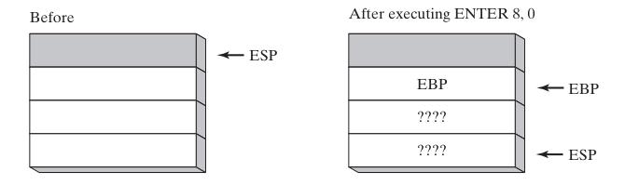

The image above shows the stack before and after the ENTER instruction has executed. The ENTER instruction has pushed the value of the EBP register onto the stack and set the EBP register to the address of the current stack frame. The ENTER instruction has also reserved 8 bytes of stack space for local variables.

LOCAL DIRECTIVE

The LOCAL directive in assembly language is used to declare local variables.

It can be used to declare named local variables of any type, including standard types such as BYTE, DWORD, and PTR WORD, as well as user-defined types such as structures.

The LOCAL directive must be placed on the line immediately following the PROC directive. Its syntax is as follows:

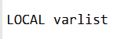

Where varlist is a list of variable definitions, separated by commas. Each variable definition takes the following form:

**label:**type where label is the name of the local variable and type is the type of the local variable.

For example, the following assembly language code declares a local variable named var1 of type BYTE:



The following assembly language code declares a doubleword local variable named temp of type DWORD and a variable named SwapFlag of type BYTE:

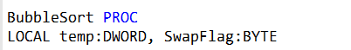

The following assembly language code declares a PTR WORD local variable named pArray, which is a pointer to a 16-bit integer:

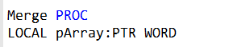

The following assembly language code declares a local variable named TempArray which is an array of 10 doublewords:

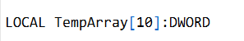

The LOCAL directive reserves stack space for the local variables that it declares. The amount of stack space reserved depends on the type and size of each local variable.

For example, a BYTE variable requires 1 byte of stack space, while a DWORD variable requires 4 bytes of stack space.

Local variables are accessible within the procedure in which they are declared. They are not accessible to other procedures.

It is important to note that the LOCAL directive is not equivalent to the ENTER instruction. The ENTER instruction creates a stack frame for a called procedure, while the LOCAL directive simply declares local variables.

The ENTER instruction must be used in conjunction with the LEAVE instruction to destroy the stack frame.

The LOCAL directive is a convenient and easy-to-use way to declare local variables in assembly language.

It is a good idea to use the LOCAL directive for all local variables, even if they are only used in a single procedure. This will make your code more readable and maintainable.

The following is a more in-depth explanation of the MASM code generation for the LOCAL directive:

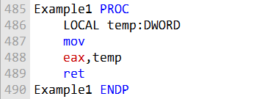

**MASM generated code:**

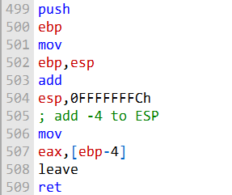

**Stack frame diagram:**

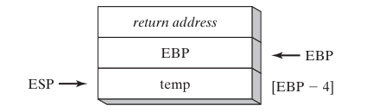

***The MASM code generator works as follows:***

It pushes the value of the EBP register onto the stack.

This saves the current value of the base pointer register. It sets the EBP register to the address of the current stack frame.

This makes the base pointer register point to the top of the new stack frame.

It subtracts 4 bytes from the ESP register.

This reserves 4 bytes of stack space for the local variable temp.

It loads the value of the local variable temp into the EAX register.

It calls the leave instruction to destroy the stack frame and restore the ESP register to its value before the enter instruction was executed.

It returns from the procedure.

***Image explanation:***

The image shows the stack before and after the Example1 procedure has executed.

The Example1 procedure has reserved 4 bytes of stack space for the local variable temp. The local variable temp is now located at the address ebp-4.

The esp register points to the top of the stack.

The ebp register points to the base of the stack frame. The base of the stack frame is the address of the first local variable.

The example1 procedure has no parameters.

Therefore, the ebp register points to the same address before and after the procedure has executed.

***Microsoft x64 calling convention***

The **Microsoft x64 calling convention** is a set of rules that govern how parameters are passed to and from functions in 64-bit Windows programs. It is used by C and C++ compilers, as well as by the Windows API library.

***Here is a summary of the key points of the Microsoft x64 calling convention:***

The first four parameters to a function are passed in registers: RCX, RDX, R8, and R9. Additional parameters are pushed onto the stack in left-to-right order.

Parameters less than 64 bits long are not zero extended, so the upper bits have indeterminate values. The return value from a function is returned in the RAX register, if it is an integer whose size is less than or equal to 64 bits.

Otherwise, the return value is placed on the stack and RCX points to its location. The caller is responsible for allocating at least 32 bytes of shadow space on the runtime stack, so called functions can optionally save the register parameters in this area.

The stack pointer (RSP) must be aligned on a 16-byte boundary when calling a function.

The caller is responsible for removing all parameters and shadow space from the runtime stack after the called function has finished.

***Here are some additional details about the Microsoft x64 calling convention:***

The CALL instruction subtracts 8 from the RSP register, since addresses are 64 bits long.

The RAX, RCX, RDX, R8, R9, R10, and R11 registers are often altered by functions, so if the calling program wants them preserved, it must push them onto the stack before the function call and pop them off the stack afterwards.

The values of the RBX, RBP, RDI, RSI, R12, R14, R14, and R15 registers must be preserved by functions.

The Microsoft x64 calling convention is a complex topic, but it is important to understand it if you are writing 64-bit Windows programs.

***Questions***

1. **(True/False): A subroutine’s stack frame always contains the caller’s return address and the subroutine’s local variables.**

Answer: True

Explanation: A subroutine’s stack frame is a region of memory on the stack that is used to store information about the subroutine, such as its local variables and the caller’s return address. The caller’s return address is the address of the instruction in the calling function that will be executed after the subroutine returns.

1. **(True/False): Arrays are passed by reference to avoid copying them onto the stack.**

Answer: True

Explanation: Arrays are typically passed by reference to functions to avoid copying them onto the stack. This is because arrays can be very large, and copying them onto the stack would be inefficient.

1. **(True/False): A subroutine’s prologue code always pushes EBP on the stack.**

Answer: True

Explanation: The prologue code for a subroutine is the code that is executed at the beginning of the subroutine. The prologue code typically saves the value of the EBP register on the stack. The EBP register is used to point to the base of the current stack frame.

1. **(True/False): Local variables are created by adding a positive value to the stack pointer.**

Answer: True

Explanation: Local variables are created by adding a positive value to the stack pointer. This value is the size of the local variable in bytes.

1. **(True/False): In 32-bit mode, the last argument to be pushed on the stack in a subroutine call is stored at location EBP + 8.**

Answer: False

Explanation: In 32-bit mode, the last argument to be pushed on the stack in a subroutine call is stored at location EBP + 4.

1. **(True/False): Passing by reference means that an argument’s address is stored on the runtime stack.**

Answer: True

Explanation: Passing by reference means that an argument’s address is stored on the runtime stack. This means that the function can directly access the argument in the calling function.

1. **What are the two common types of stack parameters?**

Answer: The two common types of stack parameters are:

Value parameters: Value parameters are copied onto the stack when the function is called. When the function returns, the changes made to the parameter on the stack are not reflected in the calling function.

Reference parameters: Reference parameters are passed by address. When a function is called with a reference parameter, the stack contains the address of the parameter in the calling function. Changes made to the parameter in the called function are also reflected in the calling function. Example:

void swap_values(int a, int b) {  
 // a and b are value parameters  
  
 int temp = a;  
 a = b;  
 b = temp;  
}  
  
void swap_references(int* a, int* b) {  
 // a and b are reference parameters  
  
 int temp = *a;  
 *a = *b;  
 *b = temp;  
}  
  
int main() {  
 int x = 10;  
 int y = 20;  
  
 // Call swap_values() with the value parameters x and y  
 swap_values(x, y);  
  
 // x and y will still be 10 and 20, respectively  
  
 // Call swap_references() with the reference parameters &x and &y  
 swap_references(&x, &y);  
  
 // x and y will now be 20 and 10, respectively  
  
 **return** 0;  
}

***Explanation:***

In the above example, the swap_values() function takes two value parameters, a and b. When the function is called, the values of a and b are copied onto the stack. The function then swaps the values of the two parameters on the stack. When the function returns, the values of a and b in the calling function are not affected.

The swap_references() function takes two reference parameters, a and b. When the function is called, the stack contains the addresses of the a and b parameters in the calling function. The function then swaps the values of the two parameters in the calling function. When the function returns, the values of a and b in the calling function are affected.

RECURSION IN ASSEMBLY LANGUAGE

**Recursion** is a programming technique where a function calls itself directly or indirectly. It can be a powerful tool for solving complex problems, but it is important to understand how it works and how to avoid writing recursive functions that can cause stack overflows.

***Endless Recursion***

The example of endless recursion you provided is a good illustration of what can go wrong when recursion is not used correctly.

The Endless procedure calls itself repeatedly without ever checking for a **base case.** As a result, the stack will continue to grow until it overflows, causing the program to crash.

To rewrite the Endless procedure correctly, we need to add a base case. This is a condition that will cause the procedure to terminate instead of calling itself again.

In the case of the Endless procedure, the base case could be something like "if the input is 0, then return".

Here is a rewritten version of the Endless procedure that includes a base case:

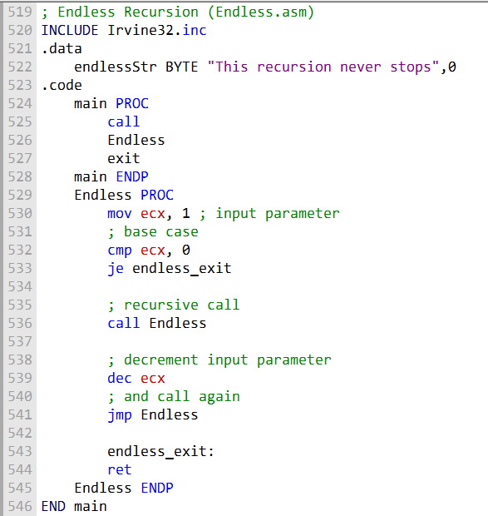

This rewritten version of the Endless procedure will now terminate correctly when the input is 0. It will also print the message "This recursion never stops" to the console before it terminates.

***When to Use Recursion***

Recursion is not a good choice for all problems. It can be inefficient and difficult to debug. However, it can be a powerful tool for solving problems that have repeating patterns. For example, recursion is often used to implement algorithms for traversing linked lists and trees.

If you are considering using recursion in your program, it is important to make sure that the problem you are trying to solve is a good fit for recursion. You should also carefully design your recursive function to avoid stack overflows.

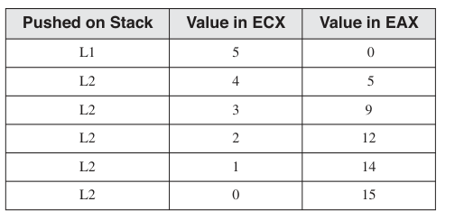

***Recursively Calculating a Sum***

A recursive procedure is one that calls itself. This can be useful for solving problems that can be broken down into smaller subproblems of the same type.

To calculate the sum of the integers from 1 to n, we can use the following recursive procedure:

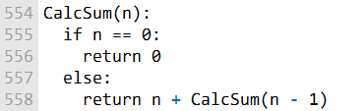

This procedure works by recursively calling itself to calculate the sum of the integers from 1 to n - 1, and then adding n to the result. The base case is when n == 0, in which case the sum is simply 0.

The following table shows a stack trace for the recursive call of CalcSum(5):

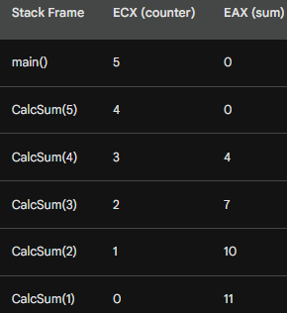

***Explanation of the Table:***

The stack frame for each recursive call is pushed onto the stack when the CALL instruction is executed. The stack frame contains the return address, which is the address of the next instruction to be executed after the recursive call returns.

The ECX register contains the counter value for the current recursive call. The EAX register contains the sum of the integers calculated so far.

At the first recursive call to CalcSum(5), the counter value is 4 and the sum is 0. The program calculates the sum of the integers from 1 to 4 by recursively calling CalcSum(4).

At the second recursive call to CalcSum(4), the counter value is 3 and the sum is 0. The program calculates the sum of the integers from 1 to 3 by recursively calling CalcSum(3).

This process continues until the base case is reached, when n == 0. At this point, the program returns 0 from the recursive call. The program then returns from the recursive call to CalcSum(3), and so on.

By the time the program returns from the recursive call to CalcSum(5), the sum of the integers from 1 to 5 has been calculated and stored in the EAX register. The program can then return the sum from the main() function.

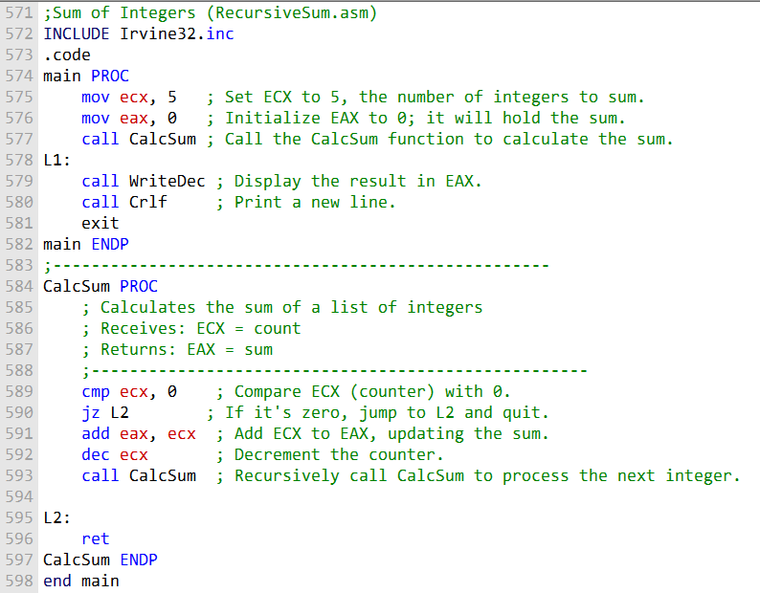

This code first sets up the main procedure, where it initializes ecx to 5 (the number of integers to sum) and eax to 0 (to store the sum). It then calls the CalcSum procedure to calculate the sum. Afterward, it prints the result using WriteDec and adds a new line with Crlf.

The CalcSum procedure is a recursive function that calculates the sum of integers. It checks if ecx (the counter) is zero; if not, it adds the current value of ecx to the sum in eax, decrements ecx, and then makes a recursive call to CalcSum. This process continues until ecx reaches 0, at which point the function returns (ret).

***Factorial of an Integer***

The Factorial procedure uses recursion to calculate the factorial of a number. It receives one **stack parameter**, N, which is the number to calculate. The calling program's return address is automatically pushed on the stack by the CALL instruction.

The first thing Factorial does is to push EBP on the stack, to save the base pointer to the calling program's stack. It then sets EBP to the beginning of the current stack frame. This allows the procedure to access its parameters and local variables using base-offset addressing.

Next, Factorial checks the base case, which is when N equals zero. In this case, Factorial returns 1, which is the factorial of 0.

If N is not equal to zero, Factorial recursively calls itself, passing in N - 1 as the parameter. This process continues until the base case is reached.

When Factorial returns from a recursive call, it multiplies the result of the recursive call by N. This is done because the factorial of N is equal to N multiplied by the factorial of N - 1.

***Example Stack Trace***

:

The following table shows a stack trace for a call to Factorial(3):

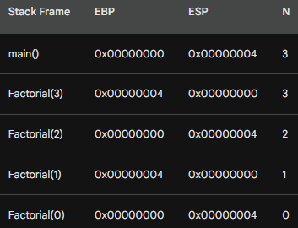

The stack frame for each recursive call is pushed onto the stack when the CALL instruction is executed. The stack frame contains the return address, which is the address of the next instruction to be executed after the recursive call returns.

The EBP register contains the base pointer to the current stack frame. The ESP register contains the stack pointer, which points to the top of the stack.

The N register contains the value of the parameter passed to Factorial.

At the first recursive call to Factorial(3), the EBP register is set to the beginning of the current stack frame. The N register is loaded with the value 3, which is the parameter passed to Factorial.

Factorial checks the base case, which is when N equals zero. Since N is not equal to zero, Factorial recursively calls itself, passing in N - 1 as the parameter.

At the second recursive call to Factorial(2), the EBP register is set to the beginning of the new stack frame. The N register is loaded with the value 2, which is the parameter passed to Factorial.

Factorial checks the base case, which is when N equals zero. Since N is not equal to zero, Factorial recursively calls itself, passing in N - 1 as the parameter.

This process continues until the base case is reached, when N equals zero. At this point, Factorial returns 1, which is the factorial of 0.

The program then returns from the recursive call to Factorial(2). The N register is loaded with the value 2, which is the result of the recursive call.

Factorial multiplies the result of the recursive call by N. This is done because the factorial of N is equal to N multiplied by the factorial of N - 1.

The program then returns from the recursive call to Factorial(3). The N register is loaded with the value 6, which is the result of the recursive call.

Factorial multiplies the result of the recursive call by N. This is done because the factorial of N is equal to N multiplied by the factorial of N - 1.

The program then returns to the main() function. The EAX register contains the value 6, which is the factorial of 3.

----------------------------------------

Let's break down the provided assembly code for calculating the factorial of an integer, explained above, step by step, and I'll explain the key parts in detail.

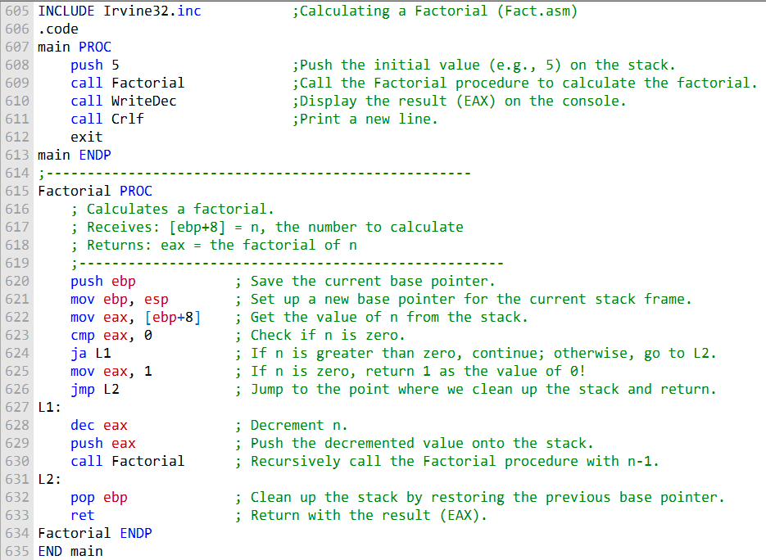

***Here's an in-depth explanation:***

The main procedure begins by pushing the initial value (5 in this case) onto the stack and then calls the Factorial procedure to calculate the factorial.

The Factorial procedure is a recursive function for calculating the factorial of an integer. It first saves the current base pointer on the stack and sets up a new base pointer for the current stack frame.

It retrieves the value of n from the stack (passed as a parameter) into the eax register.

It compares n to 0 using the cmp instruction. If n is greater than 0 (ja - jump above), it proceeds to L1; otherwise, it jumps to L2.

In L1, it decrements n and pushes the new value onto the stack. Then, it makes a recursive call to the Factorial procedure with n-1.

In L2, it pops the base pointer from the stack to clean up the stack frame and returns with the result in EAX.

This recursive approach continues to reduce n until it reaches 0, accumulating the product of each multiplication in EAX.

The result is then returned and displayed in the main procedure.

The program calculates factorials using recursion, and the result for the provided input of 5 would be 120.

***Tip:***

It is important to keep track of which registers are modified when making recursive calls to a procedure, so that you can save and restore their values if necessary. This is especially important if the register values are needed across recursive procedure calls.

--------------------------------------

1. 1. **1. (True/False): Given the same task to accomplish, a recursive subroutine usually uses more memory than a nonrecursive one.** False: Recursive subroutines typically use more memory than nonrecursive subroutines, because they require additional stack space to store the return addresses of the recursive calls.
2. 2. **2. In the Factorial function, what condition terminates the recursion?** The recursion terminates when the input parameter, n, is equal to 0.
3. **Which instructions in the assembly language Factorial procedure execute after each recursive call has finished?** The following instructions in the assembly language Factorial procedure execute after each recursive call has finished:



These instructions multiply the result of the recursive call by n. This is necessary because the factorial of n is equal to n multiplied by the factorial of n - 1.

**What would happen to the Factorial program’s output if you tried to calculate 13!?** The Factorial program would fail to calculate 13! because the factorial of 13 is too large to be represented in a 32-bit integer.

**Challenge: How many bytes of stack space would be used by the Factorial procedure when calculating 5!?** The Factorial procedure would use 20 bytes of stack space when calculating 5!. This is because the stack frame for each recursive call requires 4 bytes for the return address and 16 bytes for the local variables.

Here is a breakdown of the stack space requirements:

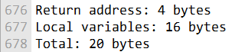

The Factorial procedure makes 5 recursive calls when calculating 5!, so the total stack space requirement is 20 bytes per recursive call * 5 recursive calls = 100 bytes.

INVOKE, ADDR, PROC AND PROTO

The INVOKE, PROC, and PROTO directives provide powerful tools for defining and calling procedures in 32-bit mode.

They are more convenient to use than the traditional CALL and PROC directives, but they mask the underlying structure of the runtime stack.

In such cases, the **PROTO directive** helps the assembler to validate procedure calls by checking argument lists against procedure declarations. This can help to prevent errors and make programs more robust.

Advanced procedure directives are more convenient to use than traditional CALL and PROC directives, but they mask the underlying structure of the runtime stack.

It is important to develop a detailed understanding of the low-level mechanics involved in subroutine calls before using advanced procedure directives.

Advanced procedure directives can be used to improve program readability and maintainability, especially when programs execute procedure calls across module boundaries.

The PROTO directive helps the assembler to validate procedure calls by checking argument lists against procedure declarations. Recommendation:

If you are new to assembly language, it is recommended that you start by learning the traditional CALL and PROC directives.

Once you have a good understanding of how subroutine calls work, you can then consider using advanced procedure directives to improve your code.

***===========================***

***INVOKE Directive***

***==========================***

The INVOKE directive is a powerful tool for calling procedures in 32-bit mode. It allows you to pass multiple arguments to a procedure using a single line of code.

The general syntax of the INVOKE directive is as follows:

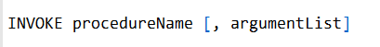

procedureName is the name of the procedure to be called.

argumentList is an optional comma-delimited list of arguments passed to the procedure.

***Arguments to INVOKE***

Arguments to INVOKE can be any valid expression, including:

* **Immediate values (e.g., 10, 3000h, OFFSET myList).**
* **Integer expressions (e.g., (1020), COUNT).**
* **Variables (e.g., myList, array, myWord, myDword).**
* **Address expressions (e.g., [myList + 2], [ebx+ esi]).**
* **Registers (e.g., eax, bl, edi).**

Arguments to INVOKE are pushed onto the stack in the reverse order that they are specified in the INVOKE statement.

The following example shows how to use the INVOKE directive to call a procedure named DumpArray():



This statement will push the following values onto the stack:

The address of the array

The length of the array

The size of the array elements

The DumpArray() procedure will then be called with these arguments.

This statement is equivalent to the following code using the CALL instruction:

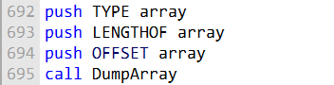

The INVOKE directive can handle almost any number of arguments, and individual arguments can appear on separate source code lines. This can be useful for documenting complex INVOKE statements or for breaking up long argument lists.

The following example shows an INVOKE statement with arguments on separate source code lines:

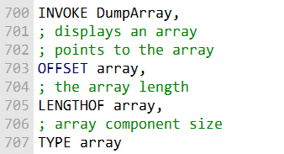

Which form you choose is a matter of personal preference. Some programmers prefer to document their code extensively, while others prefer to keep their code as concise as possible.

***Important Considerations***

When passing arguments to INVOKE that are smaller than 32 bits, the assembler may overwrite the EAX and EDX registers when it widens the arguments before pushing them onto the stack.

To avoid this behavior, you can either pass 32-bit arguments to INVOKE or save and restore the EAX and EDX registers before and after the procedure call.

The INVOKE directive is only available in 32-bit mode.

The INVOKE directive is a powerful tool for calling procedures in 32-bit mode.

It allows you to pass multiple arguments to a procedure using a single line of code.

However, it is important to be aware of the potential for overwriting the EAX and EDX registers when passing small arguments to INVOKE.

***================***

***ADDR Operator***

***================***

The ADDR operator is a powerful tool for passing pointer arguments to procedures using INVOKE. It is only available in 32-bit mode.

The ADDR operator takes a single operand, which must be an assembly time constant. This means that the operand must be known at compile time, and cannot be a variable or expression that is evaluated at runtime.

The ADDR operator returns the address of the operand. This address can then be passed to a procedure using INVOKE.

The following example shows how to use the ADDR operator to pass the address of an array to a procedure named FillArray():

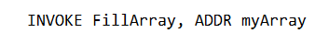

This statement is equivalent to the following code:

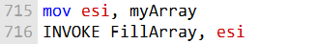

However, the first form is more concise and readable.

The ADDR operator can only be used with the INVOKE directive.

It is not valid to use the ADDR operator with other instructions, such as MOV or CALL.

The ADDR operator can only be used to pass the address of an assembly time constant.

It is not valid to pass the address of a variable or expression that is evaluated at runtime.

The following code shows how to use the ADDR operator to call a procedure named Swap() and pass it the addresses of the first two elements in an array of doublewords:

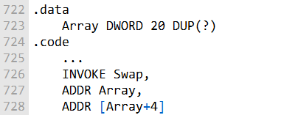

The assembler will generate the following code:

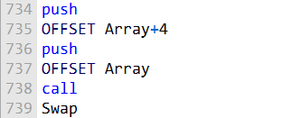

The ADDR operator is a powerful tool for passing pointer arguments to procedures using INVOKE. It allows you to write more concise and readable code.

The ADDR operator can also be used to pass the address of a function to another function. This can be useful for implementing callback functions.

For example, the following code shows how to define a function named PrintArray() that prints the elements of an array to the console:

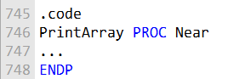

The following code shows how to pass the address of the PrintArray() function to a function named DoSomething():

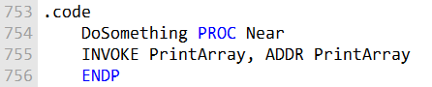

When the DoSomething() function is called, it will call the PrintArray() function to print the elements of an array to the console.

***================***

***PROC Operator***

***================***

The PROC directive is used to define a procedure in 32-bit mode. It has the following syntax:



* • **• label** is a user-defined label that follows the rules for identifiers.
* • **• attributes** is a list of optional attributes that can be used to control the behavior of the procedure. These attributes are:
* • **• distance:** Specifies whether the procedure is near or far.
* • **• langtype:** Specifies the calling convention (parameter passing convention) to use for the procedure.
* • **• visibility:** Specifies the visibility of the procedure to other modules.
* • **• prologuearg:** Specifies arguments affecting generation of prologue and epilogue code.
* • **• parameter_list** is a list of optional parameters that can be passed to the procedure.

***Parameters***

Parameters can be of any type, including bytes, words, doublewords, floating-point numbers, and pointers. To declare a parameter, you use the following syntax:

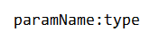

* **paramName** is the name of the parameter.
* **type** is the type of the parameter.

For example, the following procedure declares two parameters, val1 and val2, both of which are doublewords:

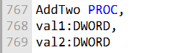

***USES***

The USES clause is an optional clause that can be used to specify which registers the procedure will need to use. This can be useful for optimizing the procedure's code.

For example, the following procedure declares that it will need to use the EAX and EBX registers:

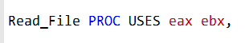

The following example shows a simple procedure named AddTwo():

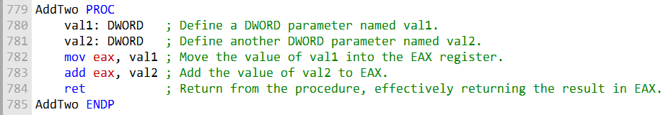

This procedure takes two doublewords as parameters and returns their sum.

The following shows the assembly code generated by MASM when assembling the AddTwo() procedure:

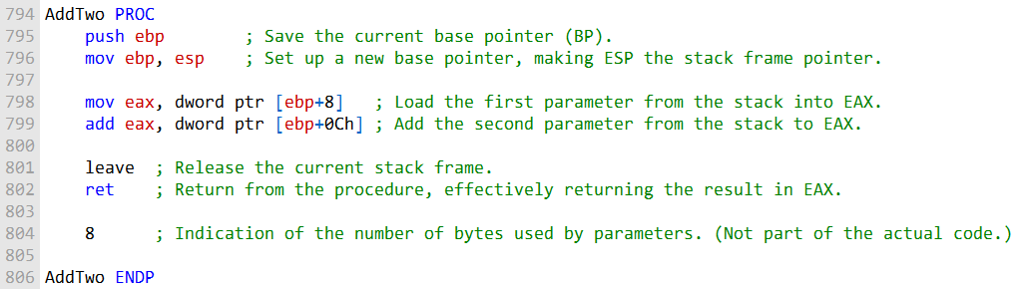

The first two lines of the generated code push the EBP register onto the stack and move the stack pointer to EBP. This is done to create a stack frame for the procedure.

The next two lines move the parameters from the stack to the EAX and EDX registers.

The next line adds the two parameters together in the EAX register.

The next two lines restore the EBP register and return from the procedure.

The constant at the end of the procedure is the size of the procedure's stack frame. This value is used by the RET instruction to pop the correct number of bytes off the stack when returning from the procedure.

The PROC directive is a powerful tool for defining procedures in 32-bit mode. It allows you to create procedures with named parameters and to control the behavior of the procedure's stack frame.

***Here's a detailed explanation of the code:***

push ebp: This instruction saves the current base pointer (BP) by pushing it onto the stack. This is a common practice to establish a proper stack frame for the procedure.

**mov ebp, esp:** The ebp register is set to the current value of esp, establishing a new stack frame for this procedure. This step aligns the base pointer with the current top of the stack (ESP) and makes it easier to access function parameters and local variables.

**mov eax, dword ptr [ebp+8]:** This line loads the first parameter (at offset +8 from the base pointer) from the stack into the EAX register. The [ebp+8] notation indicates that the first parameter is located 8 bytes above the base pointer.

**add eax, dword ptr [ebp+0Ch]:** Here, the code loads the second parameter (at offset +12 from the base pointer) from the stack and adds it to the value in EAX.

**leave:** This instruction is often used to clean up the stack frame. It's the opposite of the enter instruction. It effectively performs the following operations:

**Restores the previous value of the base pointer (EBP) from the stack.** Adjusts the stack pointer (ESP) to remove the local variables and parameters of the current function. Essentially, it unwinds the stack frame to the previous state. ret: This instruction returns from the procedure, and the value in EAX becomes the return value of the function.

The **8 at the end i**s likely a comment indicating that the parameters take up 8 bytes in total (4 bytes each), which is common for two 32-bit integers.

**In summary,** the AddTwo procedure adds two 32-bit integers passed as parameters, and the result is returned in the EAX register. The use of the base pointer (EBP) simplifies parameter access within the stack frame.

***===========================================***

***Specifying the Parameter Passing Protocol:***

***===========================================***

The parameter passing protocol specifies how parameters are passed to and from procedures. There are different parameter passing protocols, such as C, Pascal, and STDCALL.

To specify the parameter passing protocol for a procedure in assembly language, you can use the attributes field of the PROC directive.

For example, the following procedure declares that it uses the C calling convention:

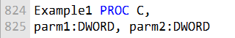

If you execute Example1() using the INVOKE directive, the assembler will generate code that is consistent with the C calling convention.

Similarly, the following procedure declares that it uses the STDCALL calling convention:

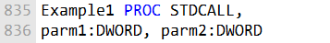

If you execute Example1() using the INVOKE directive, the assembler will generate code that is consistent with the STDCALL calling convention.

The following example shows how to use the PROC directive to declare a procedure with a specific parameter passing protocol:

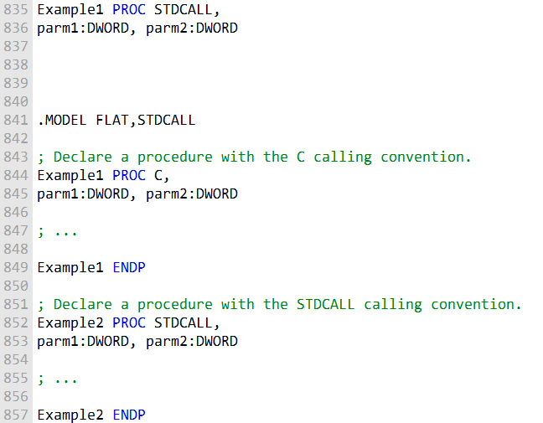

The ability to specify the parameter passing protocol for a procedure is a powerful feature that allows you to write assembly language code that can be called from other programming languages.

***===============================***

***PROTO Directive in 32-bit Mode***

***===============================***

In 32-bit mode, the **PROTO directive** is used to create a prototype for an existing procedure.

A prototype declares a procedure's name and parameter list.

It allows you to call a procedure before defining it and to verify that the number and types of arguments match the procedure definition.

The syntax of the PROTO directive is as follows:

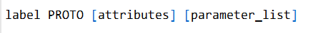

* • **• label** is the name of the procedure.
* • **• attributes** is an optional field that can be used to specify the parameter passing protocol for the procedure.
* • **• parameter_list** is an optional list of parameters that the procedure takes. Example

The following example shows how to create a prototype for a procedure named ArraySum():

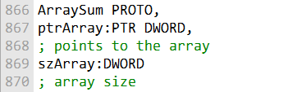

This prototype declares that the ArraySum() procedure takes two parameters: a pointer to an array of doublewords and the size of the array.

Once you have created a prototype for a procedure, you can call it using the INVOKE directive.

The INVOKE directive will verify that the number and types of arguments match the prototype before calling the procedure.

For example, the following code calls the ArraySum() procedure:

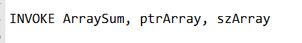

This code will call the ArraySum() procedure with the pointer to the array ptrArray and the size of the array szArray as arguments.

***Important Considerations:***

Every procedure called by the INVOKE directive must have a prototype.

The prototype for a procedure must appear before the procedure is called.

The number and types of arguments in the prototype must match the number and types of arguments in the procedure definition.

The PROTO directive is a powerful tool for writing reusable and reliable assembly language code.

It allows you to call procedures before defining them and to verify that the number and types of arguments match the procedure definition.

ASSEMBLY TIME ARGUMENT CHECKING

The PROTO directive helps the assembler check the number and types of arguments passed to a procedure when it is called. This is called assembly time argument checking.

However, assembly time argument checking is not as precise as you would find in languages like C and C++. MASM only checks for the correct number of parameters and to a limited extent, matches argument types to parameter types.

Suppose the following prototype is declared for a procedure named Sub1():

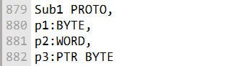

This prototype declares that the Sub1() procedure takes three parameters: a byte, a word, and a pointer to a byte.

The following is a valid call to Sub1():

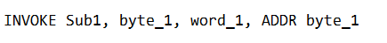

The assembler will generate the following code for this INVOKE statement:

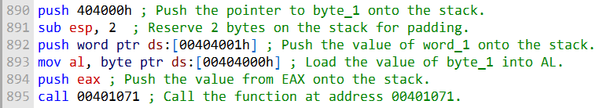

The assembler pads the stack with two bytes because the second argument (word_1) is a word, which is two bytes long.

***Errors Detected by MASM***

MASM will generate an error if an argument exceeds the size of a declared parameter. For example, the following INVOKE statement will generate an error:

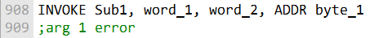

MASM will also generate errors if an INVOKE statement has too few or too many arguments. For example, the following INVOKE statements will generate errors:

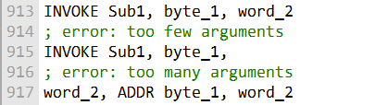

***Errors Not Detected by MASM***

MASM will not detect an error if an argument's type is smaller than a declared parameter. For example, the following INVOKE statement will not generate an error:

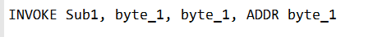

Instead, MASM will expand the smaller argument (byte_1) to the size of the declared parameter (WORD).

In the following code generated by MASM, the second argument (byte_1) is expanded into EAX before pushing it on the stack:

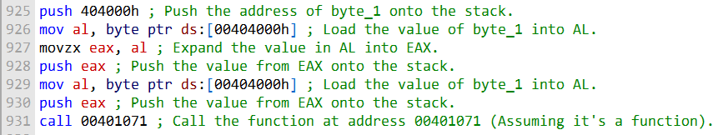

***Here's a more detailed explanation:***

**push 404000h:** This instruction pushes the pointer to byte_1 onto the stack. It's pushing an address to the stack, which may be used as a parameter for the function you're calling (at address 00401071).

**sub esp, 2:** This instruction subtracts 2 from the stack pointer (esp). It's used to reserve 2 bytes on the stack for padding. This padding might be needed to align the stack correctly, especially when dealing with functions or system calls that expect specific stack alignment.

**push word ptr ds:[00404001h]:** Here, the code pushes the value of word_1 onto the stack. It's assumed that word_1 is a 16-bit (2-byte) value. The word ptr specifies that you are dealing with a word-sized value, and it's loaded from memory address 00404001h.

**mov al, byte ptr ds:[00404000h]:** This instruction loads the value of byte_1 into the AL register. It's assumed that byte_1 is an 8-bit (1-byte) value, and it's loaded from memory address 00404000h.

**push eax:** The value from the EAX register is pushed onto the stack. This is likely done to make it available as a parameter for the function being called at address 00401071.

**call 00401071:** This instruction calls a function located at address 00401071. The behavior of this function depends on its implementation and the purpose it serves within your program.

Overall, this code appears to be setting up some parameters on the stack and then calling a function at address 00401071, passing these parameters. The specifics of how these parameters are used and the purpose of the function being called would require more context to fully understand.

***==============***

***ArraySum***

***==============***

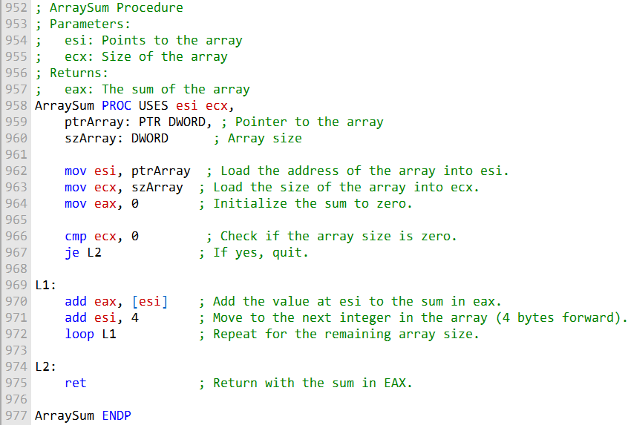

The ArraySum() procedure takes two parameters: a pointer to an array of doublewords and the size of the array. The procedure uses the ESI and ECX registers to store the address of the array and the size of the array, respectively.

The procedure begins by setting the EAX register to zero. This will be the sum of the array elements. Then, the procedure checks the size of the array. If the size is zero, the procedure simply returns. Otherwise, the procedure enters a loop.

In the loop, the procedure adds the value at the current address in the array to the EAX register. Then, the procedure increments the ESI register to point to the next element in the array. The loop repeats until all of the elements in the array have been added.

After the loop has finished, the sum of the array elements is stored in the EAX register. The procedure then returns.

Here is an example of how to call the ArraySum() procedure:

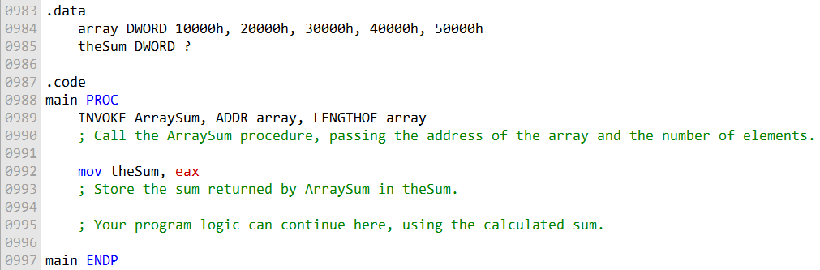

The INVOKE statement calls the ArraySum() procedure with the address of the array variable and the number of elements in the array variable as arguments.

The LENGTHOF operator is used to calculate the number of elements in the array variable.

After the ArraySum() procedure has returned, the sum of the array elements is stored in the theSum variable.

The ArraySum() example is a good example of how to use the PROC directive to declare stack parameters and how to use the INVOKE directive to call procedures with stack parameters.

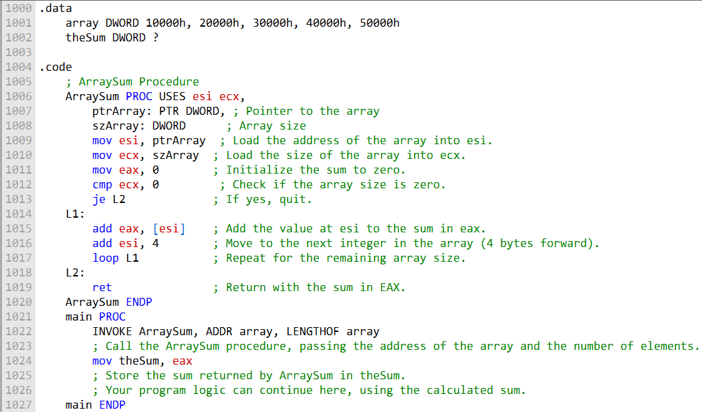

***In the .data section:***

* An array named array is defined with five DWORD (32-bit) elements and initial values.
* A DWORD variable named theSum is declared with a question mark to indicate that it's uninitialized.

***In the .code section:***

* The ArraySum procedure is defined to calculate the sum of an array of DWORDs. It expects two parameters:
* • **• ptrArray:** A pointer to the array.
* • **• szArray:** The size (number of elements) of the array. Inside ArraySum:
* • **• esi** is used to hold the address of the array.
* • **• ecx** stores the size of the array.
* • **• eax** is initialized to zero and used to accumulate the sum.
* The code checks if the array size is zero. If it is, it immediately jumps to L2, effectively quitting the procedure.
* In L1, it adds the value at the address pointed by esi to the sum in eax, increments esi by 4 to move to the next DWORD in the array, and repeats this process for the entire array size using the loop instruction.
* Finally, in L2, it returns with the sum stored in eax.

***The main procedure:***

* Calls the ArraySum procedure using the INVOKE directive and passes the address of the array and the number of elements (LENGTHOF array) as parameters.
* It stores the result (the sum) returned by ArraySum in the theSum variable.
* After this code, your program logic can continue, making use of the calculated sum stored in theSum.
* This code efficiently calculates the sum of the elements in the array and stores it in theSum.

***Parameter Classifications:***

In the context of procedure parameters, these parameters can be classified based on the direction of data transfer between the calling program and the called procedure:

Here is a simpler explanation of input and output parameters in assembly language:

**Input parameters** are passed to a procedure from the calling program. The procedure can use the data, but it cannot change it. This means that when the procedure returns, the data in the calling program will be the same as it was before the procedure was called. Input parameters are typically used when the procedure needs data to operate on, but does not need to return any data.

**Output parameters** are used to return data from a procedure to the calling program. The procedure can change the data in the output parameter, and the calling program will see the change after the procedure returns. Output parameters are typically used when the procedure needs to return data to the calling program, such as the result of a calculation.

Here is an example of an input parameter:

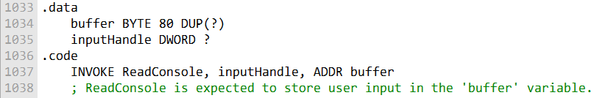

and

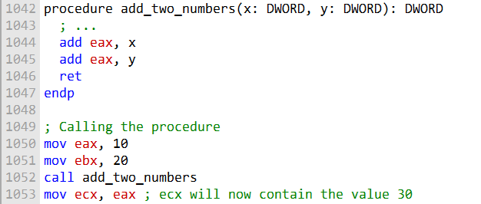

In this example, the x and y parameters are input parameters. The procedure add_two_numbers() uses the data in these parameters to calculate the sum of the two numbers. However, the procedure does not change the values of x and y.

Here is an example of an output parameter:

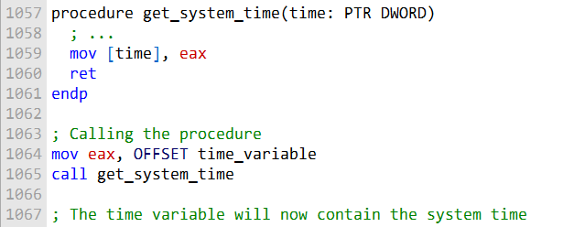

In this example, the time parameter is an output parameter. The procedure get_system_time() uses the pointer in the time parameter to store the system time in the memory location that the pointer points to.

Input and output parameters can be used together in a procedure. For example, a procedure could take an input parameter that specifies the size of an array, and it could use an output parameter to return the sum of the elements in the array.

**One example of an input/output parameter is a buffer.** A buffer is a block of memory that is used to store data temporarily. A procedure might take an input/output parameter of type buffer to read data from a file and then return the data to the calling program.

The procedure could also use the buffer to modify the data and then return the modified data to the calling program.

Here is an example of how to use an input/output parameter in assembly language:

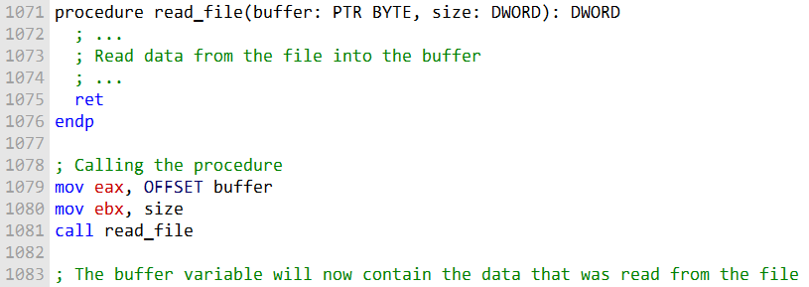

In this example, the buffer parameter is an input/output parameter. The read_file() procedure reads data from the file into the buffer.

The read_file() procedure also returns the number of bytes that were read from the file. The calling program can use this information to determine how much data is in the buffer.

***Example: Exchanging Two Integers***

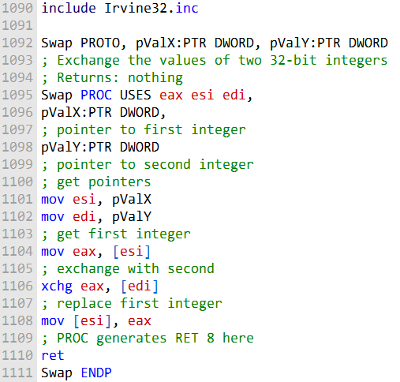

The Swap procedure takes two input/output parameters: pValX and pValY. These parameters contain the addresses of the two integers that need to be swapped.

The procedure begins by getting the pointers to the two integers.

Then, the procedure gets the value of the first integer and stores it in the EAX register.

Next, the procedure uses the **XCHG instruction** to exchange the values of the EAX register and the second integer.

Finally, the procedure stores the value of the EAX register in the first integer.

The Swap procedure does not return any value, so it simply ends with a RET instruction.

However, the PROC directive generates a RET 8 instruction at the end of the procedure, assuming that the STDCALL calling convention is being used.

The Swap procedure can be called from the main procedure as follows:

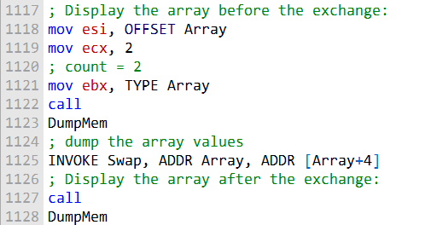

The INVOKE statement calls the Swap procedure with the addresses of the first two elements of the Array variable as arguments. After the Swap procedure returns, the first two elements of the Array variable will be swapped.

***Missing information:***

The Swap procedure does not check for errors. For example, if the addresses of the two integers are not valid, the procedure will crash.

The Swap procedure is not optimized for speed. For example, the procedure could use a temporary variable to store the value of the first integer while the second integer is being swapped.

Overall, the Swap procedure is a simple example of how to use input/output parameters in assembly language.

***===========================***

***Debugging Tips***

***===========================***

**Argument Size Mismatch**

When passing arguments to a procedure, it is important to make sure that the arguments are the correct size.

For example, if a procedure expects a doubleword pointer, you should pass a doubleword pointer.

If you pass a smaller pointer, such as a word pointer, the procedure will not be able to access the data correctly.

Here is an example of an argument size mismatch:

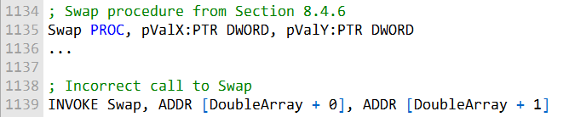

The Swap() procedure expects two doubleword pointers. However, the incorrect call to Swap() passes two word pointers.

This will cause the procedure to not be able to access the data correctly.

**Passing the Wrong Type of Pointer**

When passing arguments to a procedure, it is also important to make sure that the arguments are the correct type.

For example, if a procedure expects a doubleword pointer, you should pass a doubleword pointer. If you pass a different type of pointer, such as a byte pointer, the procedure will not be able to access the data correctly.

Here is an example of passing the wrong type of pointer:

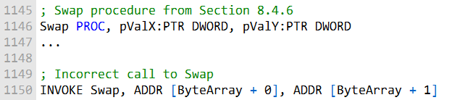

The Swap() procedure expects two doubleword pointers. However, the incorrect call to Swap() passes two byte pointers.

This will cause the procedure to not be able to access the data correctly.

**Passing Immediate Values**

You should not pass immediate values to reference parameters.

A **reference parameter** is a parameter that expects a pointer to data.

If you pass an immediate value to a reference parameter, the procedure will not be able to access the data correctly.

Here is an example of passing an immediate value to a reference parameter:

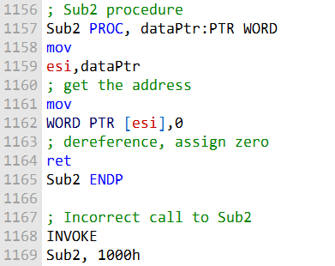

The Sub2() procedure expects a pointer to a word as its only parameter. However, the incorrect call to Sub2() passes an immediate value. This will cause the procedure to not be able to access the data correctly.

It is important to be careful when passing arguments to procedures in assembly language. If you make a mistake, it can cause the program to crash or produce incorrect results. Be sure to check the documentation for the procedure that you are calling to make sure that you are passing the correct type and number of arguments.

WIRESTACKFRAME PROCEDURE

Here is a more in-depth explanation of the WriteStackFrame and WriteStackFrameName procedures:

The Irvine32 library contains a useful procedure named WriteStackFrame that displays the contents of the current procedure’s stack frame. It shows the procedure’s stack parameters, return address, local variables, and saved registers.

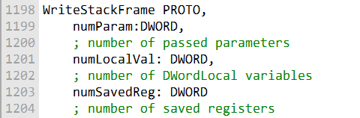

The **WriteStackFrame procedure** displays the contents of the current stack frame, which contains the stack parameters, local variables, saved registers, and return address for the current procedure.

It takes 3 parameters:

* • **• numParam -** The number of parameters passed to the current procedure. This determines how many DWORDs to show for the parameters at the top of the stack.
* • **• numLocalVal -** The number of DWORD local variables allocated on the stack for the current procedure.
* • **• numSavedReg -** The number of registers saved on the stack for the current procedure. Typically this is 2 for EAX and EBX.

It displays the stack contents by starting at EBP and moving downward to ESP. For each DWORD it displays the offset from EBP and the hex value stored there.

The parameters passed to the procedure are displayed first at the highest offsets from EBP. Then the return address, saved EBP, local variables, and saved registers are displayed in descending offset order.

ESP points to the last used stack location, so the display stops when it reaches ESP.

WriteStackFrameName does the same thing, but takes an additional parameter:

* • **• procName** - A pointer to a null-terminated string containing the name of the current procedure. This is displayed at the top of the output.

So WriteStackFrameName allows you to identify which procedure's stack frame is being displayed. This is useful when multiple procedures call WriteStackFrame/Name.

In summary, these procedures give visibility into the stack contents at any point within a procedure. This helps debug issues with stack parameters, local variables, register saving, etc.

Here is an explanation of the MASM code example that was shown in the original text:

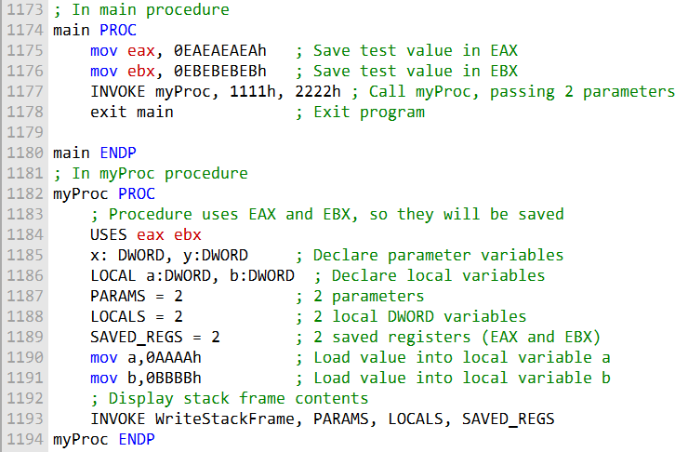

The following sample output was produced by the call:

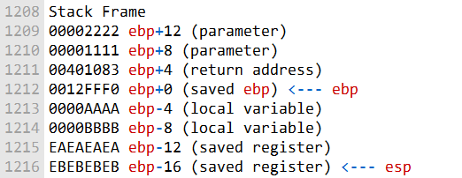

A second procedure, named WriteStackFrameName, has an additional parameter that holds the name of the procedure owning the stack frame:

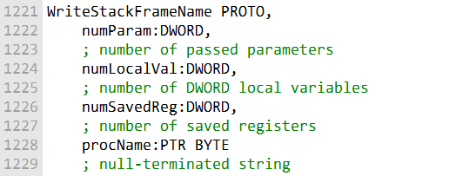

The main procedure:

* Loads some sample values into EAX and EBX to be saved on the stack later.
* Calls the myProc procedure, passing two DWORD arguments (1111h and 2222h).
* Exits the program.

The myProc procedure:

* Uses EAX, EBX registers so they will be saved on the stack.
* Declares x and y parameters and a and b local variables.
* Loads sample values into the local variables.
* Calls WriteStackFrame, passing:

**- 2 for the number of parameters**

**- 2 for the number of local DWORD variables**

**- 2 for the number of saved registers (EAX and EBX)**

This displays the contents of myProc's stack frame, including:

* **The 1111h and 2222h parameters**
* **The return address back to main**
* **The saved EBP from main**
* **The local variables a and b**
* **The saved EAX and EBX registers from main**

So, this demonstrates how WriteStackFrame can display a procedure's stack contents to help understand and debug the stack usage.

You can find the source code for the Irvine32 library in the \Examples\Lib32 directory of our book’s install directory (usually C:\Irvine). Look for the file named Irvine32.asm.

MULTIMODULE PROGRAMS

A large program can be divided into multiple modules (assembled units) to make it easier to manage and assemble. Each module is assembled independently, so a change to one module's source code only requires reassembling the single module. The linker combines all assembled modules (OBJ files) into a single executable file.

***There are two general approaches to creating multimodule programs:***

**Traditional approach:**

Using the EXTERN directive to declare external procedures and the PUBLIC directive to export procedures to other modules. Microsoft's advanced INVOKE and PROTO directives: simplify procedure calls and hide some low-level details.

**Hiding and Exporting Procedure Names**

By default, MASM makes all procedures public, permitting them to be called from any other module in the same program.

You can override this behavior using the PRIVATE qualifier or the OPTION PROC:PRIVATE directive.

**PRIVATE qualifier:** makes a single procedure private.

**OPTION PROC:PRIVATE directive:** makes all procedures in a module private by default.

You can use the PUBLIC directive to export any procedures you want.

If you use OPTION PROC:PRIVATE in your program's startup module, be sure to designate your startup procedure (usually main) as PUBLIC, or the operating system's loader will not be able to find it.

The following example shows how to create a multimodule program using the traditional approach:

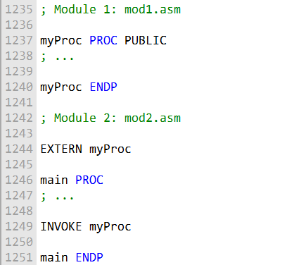

To assemble the program, you would use the following commands:

This would create an executable file called myprog.exe.

The EXTERN directive tells the assembler that the myProc() procedure is defined in another module.

The PUBLIC directive tells the assembler that the myProc() procedure can be called from other modules.

**Using the INVOKE and PROTO Directives**

The following example shows how to create a multimodule program using Microsoft's advanced INVOKE and PROTO directives:

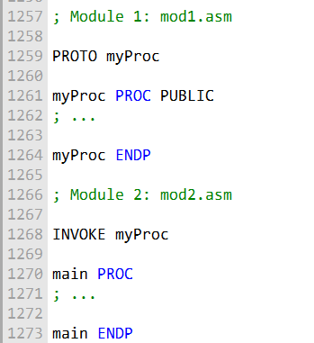

To assemble the program, you would use the following commands:

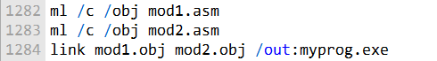

This would create an executable file called myprog.exe.

The **/c option** tells MASM to compile the source code but not link it. The **/obj option** tells MASM to generate object files. The **/out: option** tells MASM to generate an executable file with the specified name.

The PROTO directive tells the assembler about the prototype of the myProc() procedure, including its name and the number and types of its arguments.

The INVOKE directive tells the assembler to call the myProc() procedure.

The INVOKE and PROTO directives simplify procedure calls and hide some low-level details, such as the need to push and pop arguments on the stack.

CALLING EXTERNAL PROCEDURES

To call an external procedure in MASM, you use the EXTERN directive.

The EXTERN directive tells the assembler that the procedure is defined in another module and gives the procedure's name and stack frame size.

The following example shows how to call an external procedure named sub1():

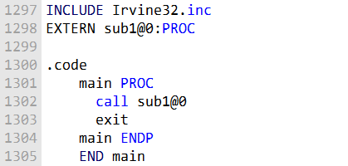

The **@0 suffix** at the end of the procedure name indicates that the procedure **does not have any parameters.**

If the procedure has parameters, you must include the **stack frame size** in the EXTERN directive.

The stack frame size is the total amount of stack space that the procedure uses to store its parameters and local variables.

The following example shows how to call an external procedure named AddTwo(), which has two doubleword parameters:

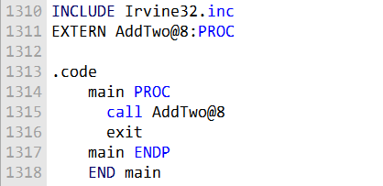

The @8 suffix at the end of the procedure name indicates that the procedure uses 8 bytes of stack space for its parameters.

You can also use the PROTO directive in place of the EXTERN directive. The PROTO directive tells the assembler about the prototype of the procedure, including its name and the number and types of its arguments.

The following example shows how to use the PROTO directive to declare the prototype of the AddTwo() procedure:

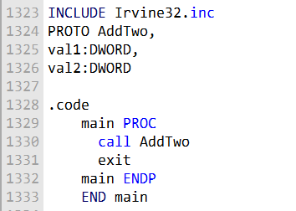

The PROTO directive tells the assembler that the AddTwo() procedure has two doubleword parameters.

When the assembler sees a call to the AddTwo() procedure, it can check to make sure that the correct number of arguments are passed to the procedure.

The EXTERN and PROTO directives are both used to call external procedures.

The EXTERN directive is simpler to use, but the PROTO directive provides more information to the assembler, which can help to prevent errors.

***Which directive should you use?***

If you are only calling a few external procedures and you are not concerned about the performance of your program, then you can use the EXTERN directive.

If you are calling a large number of external procedures or if you are concerned about the performance of your program, then you should use the PROTO directive.

The PROTO directive provides more information to the assembler, which can help to optimize the code.

***======================================================***

***Using Variables and Symbols across Module Boundaries:***

***Exporting Variables and Symbols***

***======================================================***

**What is EXTERNDEF?**

EXTERNDEF is a directive that combines the functionality of the PUBLIC and EXTERN directives. It can be used to export variables and symbols from one module and import them into another module.

**How to use EXTERNDEF?**

To use EXTERNDEF, you first need to create an include file that contains the EXTERNDEF declarations for the variables and symbols that you want to share. For example, the following include file defines two variables, count and SYM1:

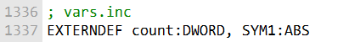

Then, you can include the include file in any module that needs to access the variables or symbols. For example, the following module exports the count and SYM1 variables:

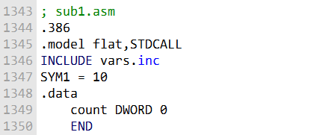

Finally, you can import the variables or symbols into any module that needs to use them. For example, the following module imports the count and SYM1 variables and uses them to calculate a value:

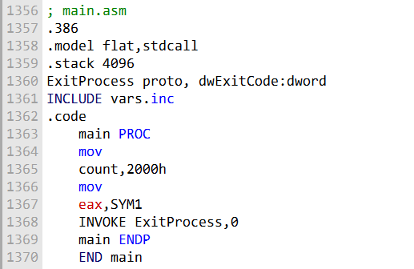

**Benefits of using EXTERNDEF**

There are several benefits to using EXTERNDEF to share variables and symbols across module boundaries:

It makes it easy to share variables and symbols between modules. It helps to reduce the amount of duplicate code.

It makes the code more modular and reusable. Conclusion

EXTERNDEF is a powerful directive that can be used to share variables and symbols across module boundaries.

It is a good practice to use EXTERNDEF to share variables and symbols between modules, as it makes the code more modular and reusable.

Let's make our program modular and see these concepts in action:

***==========================***

***ArraySum program***

***==========================***

The ArraySum program, first presented in Chapters before, is a good example of a multimodule program. The program can be divided into the following modules:

**main.asm:** The startup module, which calls the other modules to perform the program's tasks.

**promptforintegers.asm:** Prompts the user to enter an array of integers and reads the integers from the console.

**arraysum.asm:** Calculates the sum of the integers in the array.

**writeinteger.asm:** Writes an integer to the console.

The following diagram shows the structure chart of the ArraySum program:

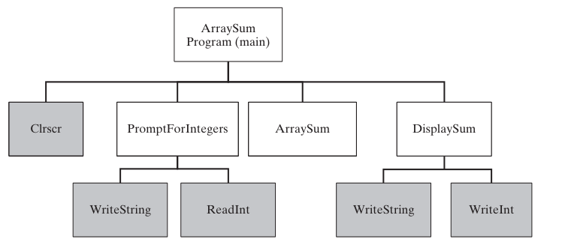

***==========================***

***Prompt for Integers***

***==========================***

; Prompt For Integers (_prompt.asm)  
INCLUDE Irvine32.**inc**  
.code  
 ;----------------------------------------------------  
 PromptForIntegers PROC  
 ; Prompts the user for an array of integers and fills  
 ; the array with the user's input.  
 ; Receives:  
 ; ptrPrompt: PTR BYTE - prompt string  
 ; ptrArray: PTR DWORD - pointer to array  
 ; arraySize: DWORD - size of the array  
 ; Returns: nothing  
 ;-----------------------------------------------------  
 arraySize EQU [ebp+16]  
 ptrArray EQU [ebp+12]  
 ptrPrompt EQU [ebp+8]  
 **enter** 0,0  
 **pushad**  
 ; save all registers  
 **mov** ecx,arraySize  
 **cmp** ecx,0  
 ; array size != 0?  
 **jle** L2  
 ; yes: quit  
 **mov** edx,ptrPrompt  
 ; address of the prompt  
 **mov** esi,ptrArray  
 L1:  
 **call** WriteString  
 ; display string  
 **call** ReadInt  
 ; read integer into EAX  
 **call** Crlf  
 ; go to next output line  
 **mov** [esi],eax  
 ; store in array  
 **add** esi,4  
 ; next integer  
 **loop** L1  
 L2:  
 **popad**  
 ; restore all registers  
 **leave**  
 **ret**  
 12  
 ; restore the stack  
 PromptForIntegers ENDP  
 end

The prompt.asm file contains the source code for the PromptForIntegers() procedure. This procedure prompts the user for an array of integers and fills the array with the user's input.

* The **PromptForIntegers()** procedure takes three parameters:
* • **• ptrPrompt:** A pointer to the prompt string.
* • **• ptrArray:** A pointer to the array.
* • **• arraySize:** The size of the array.

***The PromptForIntegers() procedure works as follows:***

It saves all of the registers.

It compares the array size to 0. If the array size is 0, the procedure exits. It displays the prompt string using the WriteString() procedure. It reads an integer from the console using the ReadInt() procedure. It stores the integer in the array.

It increments the array pointer. It repeats steps 3-6 until all of the integers have been read. It restores all of the registers. It leaves the procedure. Here is a more detailed explanation of each step:

**Step 1: Save all of the registers**

The PromptForIntegers() procedure saves all of the registers because it needs to use them and it does not want to overwrite any of the values that are in the registers when the procedure is called.

**Step 2: Compare the array size to 0**

The PromptForIntegers() procedure checks the array size to make sure that it is not 0. If the array size is 0, the procedure exits. This is because it does not make sense to prompt the user for an array of integers if the array is empty.

**Step 3: Display the prompt string**

The PromptForIntegers() procedure displays the prompt string using the WriteString() procedure. The WriteString() procedure is a library procedure that writes a string to the console.

**Step 4: Read an integer from the console**

The PromptForIntegers() procedure reads an integer from the console using the ReadInt() procedure. The ReadInt() procedure is a library procedure that reads an integer from the console and stores it in the EAX register.

**Step 5: Store the integer in the array**

The PromptForIntegers() procedure stores the integer in the array by moving the EAX register to the array element that is pointed to by the array pointer.

**Step 6: Increment the array pointer**

The PromptForIntegers() procedure increments the array pointer so that it points to the next element in the array.

**Step 7: Repeat steps 3-6 until all of the integers have been read**

The PromptForIntegers() procedure repeats steps 3-6 until all of the integers have been read. This is done by using the loop instruction. The loop instruction repeats a block of instructions until a specified condition is met. In this case, the condition is that the array pointer is not equal to the end of the array.

**Step 8: Restore all of the registers**

The PromptForIntegers() procedure restores all of the registers that it saved in step 1.

**Step 9: Leave the procedure**

The PromptForIntegers() procedure leaves the procedure by using the leave instruction. The leave instruction restores the stack frame and returns from the procedure.

The **PromptForIntegers() procedure** is a good example of how to write a procedure in assembly language. The procedure is well-structured and easy to understand. The procedure also uses library procedures to perform common tasks, such as writing a string to the console and reading an integer from the console.

**==========================**

**ArraySum program**

**==========================**

; ArraySum Procedure (_arraysum.asm)  
INCLUDE Irvine32.**inc**  
.code  
 ;-----------------------------------------------------  
 ArraySum PROC  
 ;  
 ; Calculates the sum of an array of 32-bit integers.  
 ; Receives:  
 ; ptrArray - pointer to array  
 ; arraySize - size of array (DWORD)  
 ; Returns: EAX = sum  
 ;-----------------------------------------------------  
 ptrArray EQU [ebp+8]  
 arraySize EQU [ebp+12]  
 **enter** 0,0  
 **push** ecx  
 ; don't push EAX  
 **push** esi  
 **mov** eax,0  
 ; set the sum to zero  
 **mov** esi,ptrArray  
 **mov** ecx,arraySize  
 **cmp** ecx,0  
 ; array size != 0?  
 **jle** L2  
 ; yes: quit  
 L1:  
 **add** eax,[esi]  
 ; add each integer to sum  
 **add** esi,4  
 ; point to next integer  
 **loop** L1  
 ; repeat for array size  
 L2:  
 **pop** esi  
 **pop** ecx  
 ; return sum in EAX  
 **leave**  
 **ret**  
 8  
 ; restore the stack  
 ArraySum ENDP  
 END

The code you provided is the implementation of the ArraySum() procedure in assembly language. The ArraySum() procedure calculates the sum of an array of 32-bit integers.

***The ArraySum() procedure takes two parameters:***

* ptrArray: A pointer to the array.
* arraySize: The size of the array.

***The ArraySum() procedure works as follows:***

It saves the ECX register, because it needs to use it and it does not want to overwrite the value that is in the register when the procedure is called. It sets the EAX register to 0.

This is because the EAX register will be used to store the sum of the integers in the array. It moves the pointer to the first element of the array into the ESI register. It compares the array size to 0.

If the array size is 0, the procedure exits. This is because it does not make sense to calculate the sum of an empty array.

It adds the integer at the current position in the array to the EAX register. It increments the ESI register so that it points to the next element in the array.

It repeats steps 5 and 6 until all of the integers in the array have been added to the EAX register. It restores the ECX register.

It leaves the procedure.

***Here is a more detailed explanation of each step:***

**Step 1: Save the ECX register**

The ArraySum() procedure saves the ECX register because it needs to use it and it does not want to overwrite the value that is in the register when the procedure is called.

**Step 2: Set the EAX register to 0**

The ArraySum() procedure sets the EAX register to 0 because it will be used to store the sum of the integers in the array.

**Step 3: Move the pointer to the first element of the array into the ESI register**

The ArraySum() procedure moves the pointer to the first element of the array into the ESI register. This is because the ESI register will be used to iterate through the array.

**Step 4: Compare the array size to 0**

The ArraySum() procedure checks the array size to make sure that it is not 0. If the array size is 0, the procedure exits. This is because it does not make sense to calculate the sum of an empty array.

**Step 5: Add the integer at the current position in the array to the EAX register**

The ArraySum() procedure adds the integer at the current position in the array to the EAX register. This is done using the add instruction. The add instruction adds two operands and stores the result in the first operand.

**Step 6: Increment the ESI register so that it points to the next element in the array**

The ArraySum() procedure increments the ESI register so that it points to the next element in the array. This is done using the inc instruction. The inc instruction increments the value of the operand by 1.

**Step 7: Repeat steps 5 and 6 until all of the integers in the array have been added to the EAX register**

The ArraySum() procedure repeats steps 5 and 6 until all of the integers in the array have been added to the EAX register.

This is done using the loop instruction. The loop instruction repeats a block of instructions until a specified condition is met.

In this case, the condition is that the ESI register is not equal to the value of the ptrArray parameter.

**Step 8: Restore the ECX register**

The ArraySum() procedure restores the ECX register.

Step 9: Leave the procedure

The ArraySum() procedure leaves the procedure by using the leave instruction. The leave instruction restores the stack frame and returns from the procedure.

The ArraySum() procedure is a good example of how to write a procedure in assembly language. The procedure is well-structured and easy to understand. The procedure also uses a loop to iterate through the array, which is a common technique in assembly language.

***==========================***

***Display Sum Proc***

***==========================***

; DisplaySum Procedure (_display.asm)  
INCLUDE Irvine32.**inc**  
.code  
 ;-----------------------------------------------------  
 DisplaySum PROC  
 ; Displays the sum on the console.  
 ; Receives:  
 ; ptrPrompt - offset of the prompt string  
 ; theSum - the array sum (DWORD)  
 ; Returns: nothing  
 ;-----------------------------------------------------  
 theSum EQU [ebp+12]  
 ptrPrompt EQU [ebp+8]  
 **enter** 0,0  
 **push** eax  
 **push** edx  
 **mov** edx,ptrPrompt  
 ; pointer to prompt  
 **call** WriteString  
 **mov** eax,theSum  
 **call** WriteInt  
 ; display EAX  
 **call** Crlf  
 **pop** edx  
 **pop** eax  
 **leave**  
 **ret**  
 8  
 ; restore the stack  
 DisplaySum ENDP  
 END

The code you provided is the implementation of the DisplaySum() procedure in assembly language. The DisplaySum() procedure displays the sum of an array of 32-bit integers on the console.

The DisplaySum() procedure takes two parameters:

* • **• ptrPrompt:** A pointer to the prompt string.
* • **• theSum:** The sum of the integers in the array. The DisplaySum() procedure works as follows:

It saves the EAX and EDX registers, because it needs to use them and it does not want to overwrite the values that are in the registers when the procedure is called. It moves the pointer to the prompt string into the EDX register.

It calls the WriteString() procedure to display the prompt string on the console. It moves the sum of the integers in the array into the EAX register.

It calls the WriteInt() procedure to display the sum of the integers in the array on the console.

It calls the Crlf() procedure to move the cursor to the next line on the console. It restores the EAX and EDX registers.

It leaves the procedure.

***Here is a more detailed explanation of each step:***

**Step 1: Save the EAX and EDX registers**

The DisplaySum() procedure saves the EAX and EDX registers because it needs to use them and it does not want to overwrite the values that are in the registers when the procedure is called.

**Step 2: Move the pointer to the prompt string into the EDX register**

The DisplaySum() procedure moves the pointer to the prompt string into the EDX register. This is because the EDX register will be used to pass the pointer to the prompt string to the WriteString() procedure.

**Step 3: Call the WriteString() procedure to display the prompt string on the console**

The DisplaySum() procedure calls the WriteString() procedure to display the prompt string on the console. The WriteString() procedure is a library procedure that writes a string to the console.

**Step 4: Move the sum of the integers in the array into the EAX register**

The DisplaySum() procedure moves the sum of the integers in the array into the EAX register. This is because the EAX register will be used to pass the sum of the integers in the array to the WriteInt() procedure.

**Step 5: Call the WriteInt() procedure to display the sum of the integers in the array on the console**

The DisplaySum() procedure calls the WriteInt() procedure to display the sum of the integers in the array on the console. The WriteInt() procedure is a library procedure that writes an integer to the console.

**Step 6: Call the Crlf() procedure to move the cursor to the next line on the console**

The DisplaySum() procedure calls the Crlf() procedure to move the cursor to the next line on the console. The Crlf() procedure is a library procedure that moves the cursor to the next line on the console.

**Step 7: Restore the EAX and EDX registers**

The DisplaySum() procedure restores the EAX and EDX registers.

**Step 8: Leave the procedure**

The DisplaySum() procedure leaves the procedure by using the leave instruction. The leave instruction restores the stack frame and returns from the procedure.

The DisplaySum() procedure is a good example of how to write a procedure in assembly language. The procedure is well-structured and easy to understand. The procedure also uses library procedures to perform common tasks, such as writing a string to the console and writing an integer to the console.

***==============***

***Sum_main.asm***

***=============***

; Integer Summation Program (Sum_main.asm)  
; Multimodule example:  
; This program inputs multiple integers from the user,  
; stores them in an array, calculates the sum of the  
; array, and displays the sum.  
INCLUDE Irvine32.**inc**  
INCLUDE macros.asm ; Include for INVOKE and PROTO  
  
EXTERN PromptForIntegers:PROC  
EXTERN ArraySum:PROC  
EXTERN DisplaySum:PROC  
  
; Modify Count to change the size of the array:  
Count = 3  
  
.data  
prompt1 BYTE "Enter a signed integer: ",0  
prompt2 BYTE "The sum of the integers is: ",0  
array DWORD Count DUP(?)  
sum DWORD ?  
  
.code  
main PROC  
 **call** Clrscr  
 ; PromptForIntegers(ADDR prompt1, ADDR array, Count)  
 INVOKE PromptForIntegers, ADDR prompt1, ADDR array, Count  
   
 ; sum = ArraySum(ADDR array, Count)  
 INVOKE ArraySum, ADDR array, Count  
 **mov** sum, eax  
   
 ; DisplaySum(ADDR prompt2, sum)  
 INVOKE DisplaySum, ADDR prompt2, sum  
 **call** Crlf  
 exit  
main ENDP  
  
END main

This code retains the same functionality as the original version but utilizes Microsoft's INVOKE and PROTO directives for calling procedures, making the code more structured and easier to read.

The code you provided is a multimodule example of an integer summation program. The program inputs multiple integers from the user, stores them in an array, calculates the sum of the array, and displays the sum.

***The program is divided into three modules:***

**Sum_main.asm:** This is the main module, which contains the main() procedure. The main() procedure is responsible for calling the other modules to perform the program's tasks.

**promptforintegers.asm:** This module contains the PromptForIntegers() procedure, which prompts the user for multiple integers and stores them in an array.

**arraysum.asm:** This module contains the ArraySum() procedure, which calculates the sum of the integers in an array.

**display.asm:** This module contains the DisplaySum() procedure, which displays the sum of the integers in an array on the console.

**The Sum_main.asm module is the main module of the program. The main() procedure in this module performs the following steps:**

It calls the Clrscr() procedure to clear the console screen. It calls the PromptForIntegers() procedure to prompt the user for multiple integers and store them in an array. It calls the ArraySum() procedure to calculate the sum of the integers in the array.

It calls the DisplaySum() procedure to display the sum of the integers in the array on the console. It calls the Crlf() procedure to move the cursor to the next line on the console. It calls the exit() procedure to exit the program.

The promptforintegers.asm module contains the PromptForIntegers() procedure. This procedure prompts the user for multiple integers and stores them in an array. The procedure takes the following parameters:

* • **• ptrPrompt:** A pointer to the prompt string.
* • **• ptrArray:** A pointer to the array.
* **Count:** The number of integers to prompt the user for.

***The PromptForIntegers() procedure works as follows:***

It iterates over the array and prompts the user for each integer. It stores the integer that the user enters in the array.

It repeats steps 1 and 2 until all of the integers have been entered. The arraysum.asm module contains the ArraySum() procedure. This procedure calculates the sum of the integers in an array. The procedure takes the following parameters:

* ptrArray: A pointer to the array.
* Count: The number of integers in the array.

***The ArraySum() procedure works as follows:***

It initializes the sum to 0.

It iterates over the array and adds each integer to the sum. It returns the sum. The display.asm module contains the DisplaySum() procedure.

This procedure displays the sum of the integers in an array on the console. The procedure takes the following parameters:

* • **• ptrPrompt:** A pointer to the prompt string.
* • **• theSum:** The sum of the integers in the array.

The DisplaySum() procedure works as follows:

It displays the prompt string on the console. It displays the sum of the integers in the array on the console. It moves the cursor to the next line on the console.

The integer summation program is a good example of how to use multiple modules to write a program. By dividing the program into modules, we can make the program more modular, reusable, and maintainable.

***=========================================***

***Creating Modules using INVOKE and PROTO***

***=========================================***

Creating the Modules Using INVOKE and PROTO section are the use of the INVOKE, PROTO, and PROC directives. These directives are used to create multimodule programs in 32-bit mode.

The INVOKE directive is used to call a procedure in another module. The PROTO directive is used to declare a prototype for a procedure. The PROC directive is used to define a procedure.

The following table shows the differences between the traditional use of CALL and EXTERN and the use of INVOKE, PROTO, and PROC:

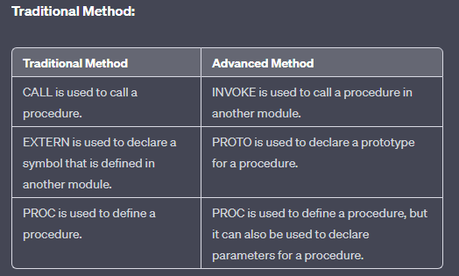

The **main advantage of using the INVOKE, PROTO, and PROC directives** is that they allow the assembler to match up the argument lists passed by INVOKE to the corresponding parameter lists declared by PROC. This helps ensure that the program is correct and that it does not crash.

Example Using INVOKE, PROTO, and PROC:

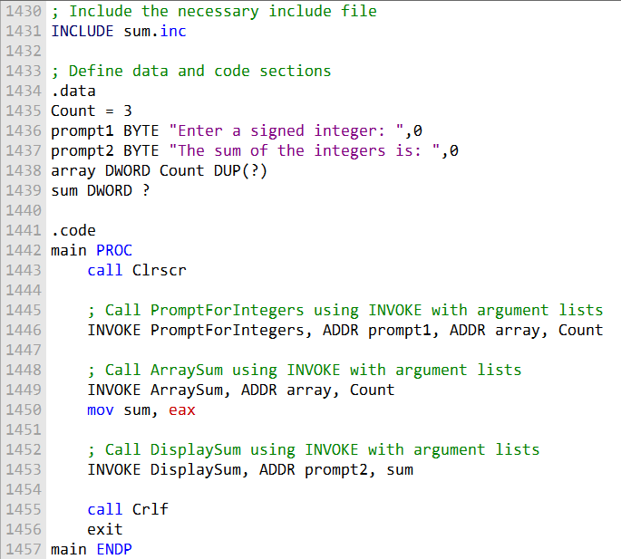

These are all the functions using advanced methods:

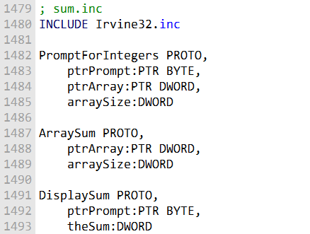

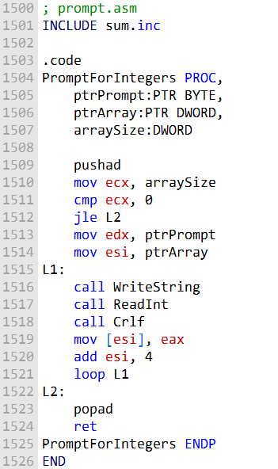

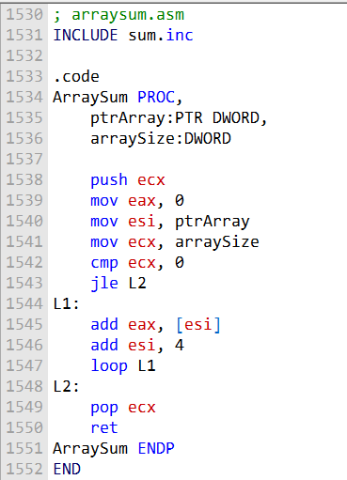



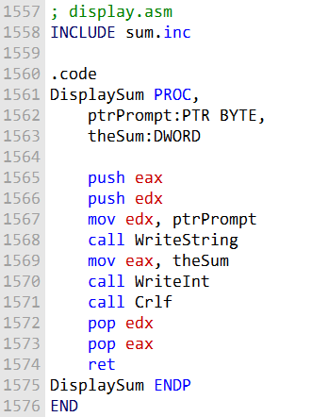

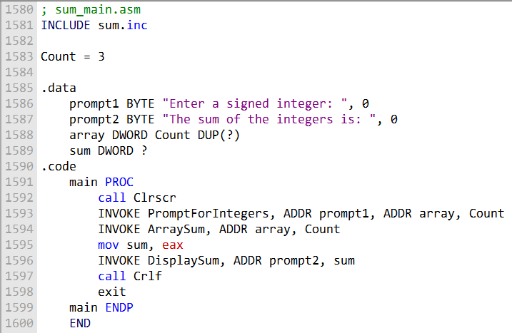

Here is a summary of the two ways to create multimodule programs:

**Traditional method:**

Use the EXTERN directive to declare symbols that are defined in another module. Use the CALL directive to call procedures in other modules.

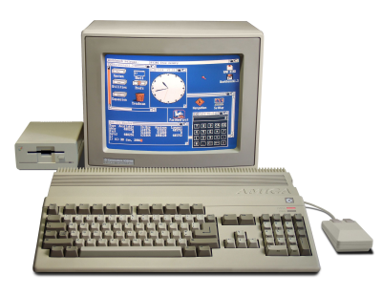

**Advanced method:**

Use the PROTO directive to declare prototypes for procedures in other modules. Use the INVOKE directive to call procedures in other modules. Use the PROC directive to define procedures, and declare parameters for procedures. The advanced method is simpler to use and more efficient, but it is only available in 32-bit mode.



**Conclusion:**

The advanced method is the preferred method for creating multimodule programs in 32-bit mode. It is simpler to use and more efficient than the traditional method. However, the traditional method is still supported, and it may be necessary for some programs.

ADVANCED OPTIONAL TOPIC 1 – USES OPERATOR

The USES operator is a powerful tool that can be used to save and restore registers at the beginning and end of a procedure.

However, it should not be used when declaring procedures that access their stack parameters using constant offsets such as [ebp + 8].

The following MySub1 procedure employs the USES operator to save and restore ECX and EDX:

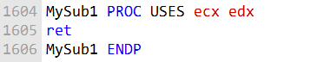

The following code is generated by MASM when it assembles MySub1:

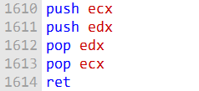

Suppose we combine USES with a stack parameter, as does the following MySub2 procedure. Its parameter is expected to be located on the stack at EBP+8:

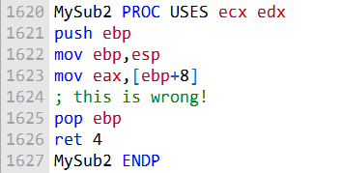

Here is the corresponding code generated by MASM for MySub2:

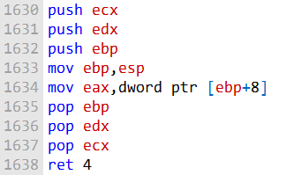

An error results because the assembler inserted the PUSH instructions for ECX and EDX at the beginning of the procedure, altering the offset of the stack parameter.

Figure 8-6 below shows how the stack parameter must now be referenced as [EBP+16]. USES modifies the stack before saving EBP, which corrupts the standard prologue code commonly used for subroutines.

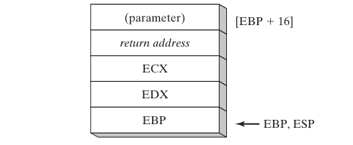

This is why it is important to avoid using the USES operator when declaring procedures that access their stack parameters using constant offsets.

If you need to save and restore registers in such a procedure, you can use the PUSH and POP instructions explicitly.

Here is a more in-depth explanation of why the USES operator causes problems in this case:

When a procedure is called, the caller pushes the procedure's arguments onto the stack.

The procedure then saves its caller-saved registers (EBP, ESI, EDI, and EBX) onto the stack. The procedure's base pointer (EBP) is set to point to the top of the stack frame.

The USES operator tells the assembler to save and restore the specified registers at the beginning and end of the procedure.

When the USES operator is used in a procedure that accesses its stack parameters using constant offsets, the assembler inserts the PUSH and POP instructions for the specified registers at the beginning and end of the procedure.

This corrupts the standard prologue code commonly used for subroutines, which relies on the stack pointer (ESP) to be pointing to the top of the stack frame.

In the example of MySub2, the USES operator is used to save and restore ECX and EDX. When MySub2 is called, its argument is pushed onto the stack.

The USES operator then causes the assembler to push ECX and EDX onto the stack. This corrupts the stack frame, because the stack pointer is now pointing to the wrong location.

To avoid this problem, you should not use the USES operator in procedures that access their stack parameters using constant offsets.

If you need to save and restore registers in such a procedure, you can use the PUSH and POP instructions explicitly.

PASSING 8-BIT AND 16-BIT ARGUMENTS ON THE STACK

***Passing 8-bit Arguments***

When passing stack arguments to procedures in 32-bit mode, it is best to push 32-bit operands.

This is because the stack pointer (ESP) must be aligned on a doubleword boundary.

If 16-bit operands are pushed onto the stack, ESP will not be aligned and a page fault may occur. Additionally, runtime performance may be degraded.

If you need to pass a 16-bit operand to a procedure in 32-bit mode, you can use the MOVZX instruction to expand the operand to 32 bits before pushing it onto the stack.

For example, the following Uppercase procedure receives a character argument and returns its uppercase equivalent in AL:

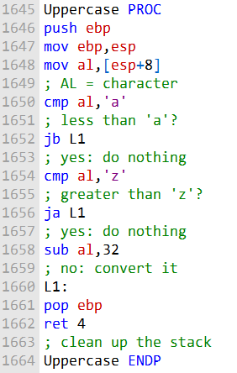

If we pass a character literal to Uppercase, the PUSH instruction will automatically expand the character to 32 bits:

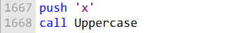

However, if we pass a character variable to Uppercase, the PUSH instruction will not allow us to push an 8-bit operand onto the stack.

To work around this, we can use the MOVZX instruction to expand the character into EAX before pushing it onto the stack:

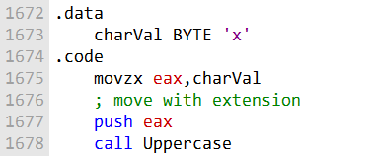

This will ensure that ESP is aligned on a doubleword boundary and that the call to Uppercase is successful.

***Passing 16-bit Arguments.***

The AddTwo procedure expects two 32-bit integer arguments (the two integers to be added). However, the word1 and word2 variables are 16-bit integers.

Therefore, if we push word1 and word2 onto the stack and call AddTwo, the procedure will not be able to correctly add the two integers.

To fix this, we can zero-extend each argument before pushing it onto the stack. Zero-extension means that the high-order 16 bits of the argument are set to zero.

This will effectively convert the 16-bit argument to a 32-bit argument.

The following code correctly calls AddTwo by zero-extending each argument before pushing it onto the stack:

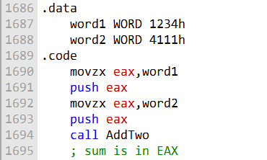

The **MOVZX instruction** is used to zero-extend the 16-bit word1 and word2 variables into the 32-bit EAX register.

Once the arguments have been zero-extended, they are pushed onto the stack in reverse order (word2 first, then word1).

When AddTwo is called, it will pop the two arguments off the stack and add them together. The sum of the two integers will be returned in the EAX register.

It is important to note that the caller of a procedure must ensure that the arguments it passes are consistent with the parameters expected by the procedure.

In the case of stack parameters, the order and size of the parameters are important.

If the caller passes the wrong number of arguments, or if the arguments are in the wrong order or have the wrong size, the procedure may not work correctly or may even crash.

***Passing 64-bit Arguments***

To pass 64-bit integer arguments to procedures in 32-bit mode, we must push the high-order doubleword of the argument first, followed by the low-order doubleword.

This is because the stack grows downwards, so the lower order doubleword of the argument will be at the lower address on the stack.

The following WriteHex64 procedure displays a 64-bit integer in hexadecimal:

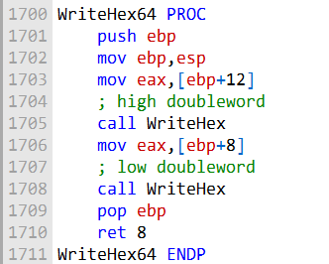

The following sample call to WriteHex64 pushes the upper half of longVal, followed by the lower half:

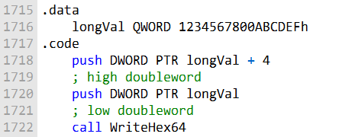

Figure below shows the stack frame inside WriteHex64 just after EBP was pushed on the stack and ESP was copied to EBP:

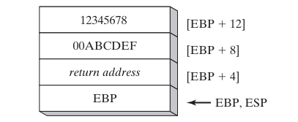

Or

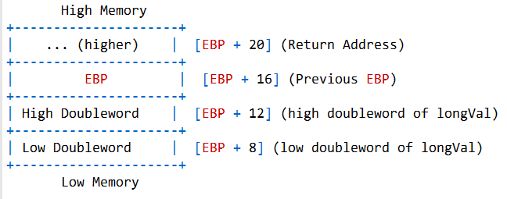

The WriteHex64 procedure can then easily retrieve the high and low doublewords of the argument from the stack and display them in hexadecimal.

It is important to note that the caller of a procedure must ensure that the arguments it passes are consistent with the parameters expected by the procedure.

In the case of stack parameters, the order and size of the parameters are important.

If the caller passes the wrong number of arguments, or if the arguments are in the wrong order or have the wrong size, the procedure may not work correctly or may even crash.

Here is a more in-depth explanation of why we must push the high-order doubleword of a 64-bit integer first when passing it to a procedure in 32-bit mode:

In 32-bit mode, the stack grows downwards. This means that when we push a value onto the stack, the stack pointer (ESP) is decremented.

When we pop a value off the stack, ESP is incremented.

When we pass a 64-bit integer to a procedure in 32-bit mode, we must push the high-order doubleword of the integer first, followed by the low-order doubleword.

This is because we want the integer to be stored on the stack in little-endian order.

In **little-endian order**, the low-order byte of the integer is stored at the lowest address on the stack.

If we were to push the low-order doubleword of the integer first, followed by the high-order doubleword, the integer would be stored on the stack in big-endian order.

In **big-endian order,** the high-order byte of the integer is stored at the lowest address on the stack.

The following diagram shows how a 64-bit integer is stored on the stack in little-endian order:

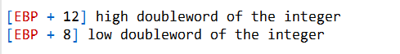

The WriteHex64 procedure can then easily retrieve the high and low doublewords of the integer from the stack and display them in hexadecimal.

Why is it important to ensure that the arguments passed to a procedure are consistent with the parameters expected by the procedure?

The caller of a procedure must ensure that the arguments it passes are consistent with the parameters expected by the procedure.

This is because the procedure is expecting certain values to be passed to it in a certain order.

If the caller passes the wrong number of arguments, or if the arguments are in the wrong order or have the wrong size, the procedure may not work correctly or may even crash.

For example, if the WriteHex64 procedure expects one 64-bit integer argument, and the caller passes two 64-bit integer arguments, the procedure will not be able to correctly display the two integers.

Or, if the caller passes a 32-bit integer argument instead of a 64-bit integer argument, the procedure will also not be able to correctly display the integer.

It is important to note that the compiler will not check to make sure that the caller is passing the correct number of arguments to a procedure, or that the arguments are in the correct order or have the wrong size. This is the responsibility of the programmer.

***Non-Doubleword Local Variables***

In 32-bit mode, the stack grows downwards. This means that when we push a value onto the stack, the stack pointer (ESP) is decremented.

When we pop a value off the stack, ESP is incremented.

When we declare a local variable in a procedure, MASM will allocate space for it on the stack. The size of the space allocated will depend on the size of the variable.

For example, if we declare a byte variable, MASM will allocate one byte of space on the stack. If we declare a doubleword variable, MASM will allocate four bytes of space on the stack.

If we declare a local variable of a size that is not a multiple of four bytes (such as a byte or a word), MASM will round the size of the variable up to the next multiple of four bytes.

This is because the stack is aligned on a doubleword boundary. This means that all addresses on the stack must be divisible by four.

For example, if we declare a byte variable named var1 in the Example1 procedure, MASM will allocate four bytes of space for it on the stack, even though the variable is only one byte in size. The remaining three bytes will be unused.

The following diagram shows how the stack looks after the Example1 procedure has been compiled and assembled:

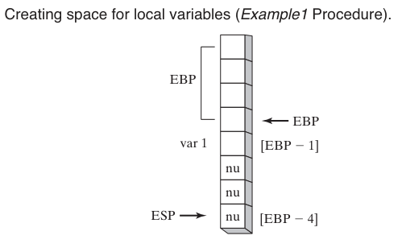

The nu blocks represent unused bytes. The following diagram shows how the stack looks after the Example2 procedure has been compiled and assembled:

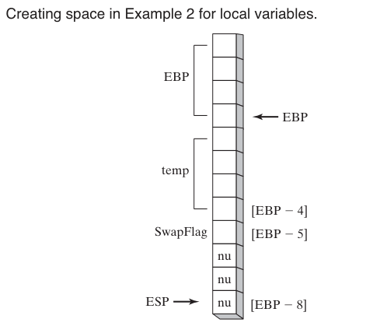

The temp variable is a doubleword variable, so it is aligned on a doubleword boundary.

The SwapFlag variable is a byte variable, but it is still allocated four bytes of space on the stack because the stack is aligned on a doubleword boundary.

***Stack size for nested procedure calls***

The stack size required for nested procedure calls is the sum of the stack sizes required for each individual procedure call.

This is because the stack is used to store the local variables and return addresses for all active procedure calls.

For example, in the following code:

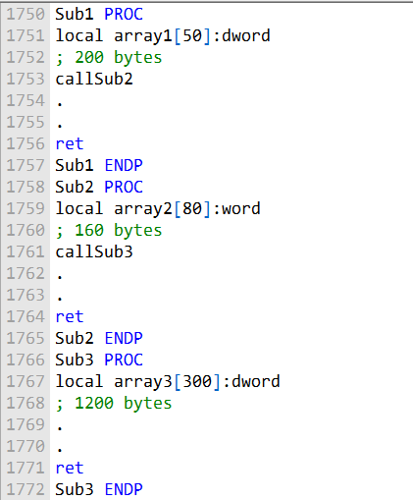

The stack size required for Sub1 is 200 bytes, the stack size required for Sub2 is 160 bytes, and the stack size required for Sub3 is 1200 bytes. Therefore, the total stack size required for this code is 1560 bytes.

This stack size is the minimum amount of stack space that must be available in order for this code to execute correctly. If there is not enough stack space available, the program will crash.

Recursive procedure calls

If a procedure is **called recursively**, the stack space it uses will be approximately the size of its local variables and parameters multiplied by the estimated depth of the recursion.

For example, if a procedure has 100 bytes of local variables and parameters, and it is called recursively to a depth of 10, then the procedure will use approximately 1000 bytes of stack space.

***Stack overflow***

If the stack space required for a program exceeds the amount of stack space available, the program will crash. This is called a **stack overflow.**

To avoid stack overflows, it is important to be aware of the s**tack space requirements of your program.** You can use the **STACK directive** to reserve additional stack space if necessary.

The stack size required for nested procedure calls is the sum of the stack sizes required for each individual procedure call.

If a procedure is called recursively, the stack space it uses will be approximately the size of its local variables and parameters multiplied by the estimated depth of the recursion.

To avoid stack overflows, it is important to be aware of the stack space requirements of your program and to reserve additional stack space, if necessary.

***Here is a summary of the key points from the chapter:***

* There are two types of procedure parameters: register parameters (faster, used by Irvine libraries) and stack parameters (more flexible).
* A stack frame is the region of stack used by a procedure for its parameters, local variables, saved registers, and return address.
* Parameters can be passed by value (copied) or by reference (address passed). Arrays should be passed by reference.
* Stack parameters are accessed using EBP offset addressing like [EBP-8]. LEA is good for getting stack parameter addresses.
* ENTER/LEAVE instructions manage the stack frame set up/teardown.
* Recursive procedures call themselves directly or indirectly. Recursion works well with repeating data structures.
* Local variables have restricted scope, lifetime tied to the procedure, don't cause naming clashes, and enable recursion.
* INVOKE directive calls procedures with multiple arguments. ADDR passes pointers.
* PROC declares procedures, PROTO prototypes existing procedures.
* Large programs should be split into multiple source code modules for manageability.
* Java bytecode is the machine language in compiled Java programs. The JVM executes it. Bytecodes use a stack-oriented model.